Journey to the Heart of France

September 24 - October 8, 2018

Journeys International, Inc.

& Rosa Ramírez Carlson

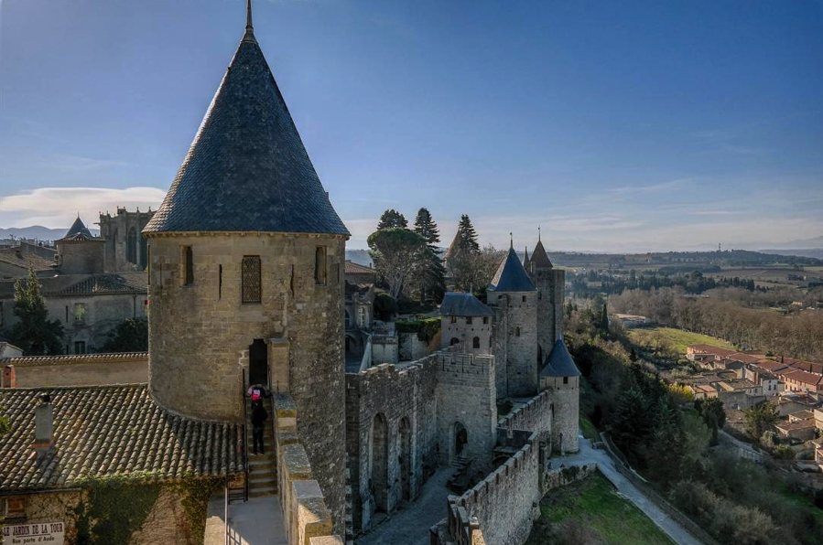

Join us for a spectacular group tour through Southern France! We are delighted to lead you through one of the most historical and beautiful destinations in Europe.
We will be traveling throughout Languedoc, the Midi-Pyrénées and the Dordogne Valley. We will visit the fantastic medieval villages of Rocamadour, Sarlat and Saint Cirq Lapopie. We will taste cheese in Roquefort, tour the beautiful Gorges du Tarn, visit the old city of Rodez with its lovely cathedral and market, wine taste in Marcillac, explore the Cathar Castles of Lastours and Cucugan, tour the fascinating cities of Albi and Cahors, explore the 11th century Abbaye de Fontfroide and the incredible cave system at Padirac. We will also enjoy the architectural splendor of the fortified medieval town of Carcassone, meander through the ancient trading port of Montpelier and relish in the elegance, romance and diversity of Paris.

Journeys International has scheduled this comprehensive 15-day tour to explore some of the most spectacular sights France has to offer! Space is limited; please join us on this very special adventure!

Day 1 – Monday, Sep 24: USA - Paris
Depart Albuquerque on American Airlines at 11:55A and arrive in Paris at CDG at 9:40am the next morning.

Day 2 – Tuesday, Sep 25: Paris - Sarlat

Overnight in Sarlat – Hotel La Hoirie or similar (L, D)

After our overnight flight, we will arrive at CDG airport in Paris at 9:40am. Once we gather our luggage, we will take a chartered bus to Sarlat. We will stop for lunch along the way.
​
Sarlat
Sarlat-la-Canéda is an essential place to visit for any fans of architecture. Its medieval old town is the perfect place to wander around with its maze of picturesque narrow streets and Gothic and Renaissance mansions. The end of the Hundred Years' War in 1453 led to the construction of lovely urban buildings in the Dordogne, and Sarlat was especially favored: when the English handed the region back to the French king, he rewarded loyal townspeople here with royal privileges. Before long, a new merchant class sprang up, building sublime stone mansions in the latest French Renaissance style.

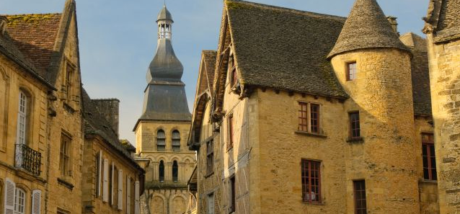

Sarlat

Day 3 – Wednesday, Sep 26th: Rocamadour - Padirac

Overnight in Sarlat – Hotel La Hoirie or similar (B, L)

Today we will enjoy an early visit to the Sarlat farmer's market to see a collection of regional vendors. Afterward, we will drive to Padirac for a guided visit to the incredible underground caves at Gouffre de Padirac. This amazing cave system contains an underground river, gorge and a huge cavern. Underground lakes, pools and stalactite formations all add to its appeal but somehow it is the sheer size of the caverns that is really astonishing. It is the most visited cave system in France and one of the most popular destinations of the Midi-Pyrenees region. After lunch we will proceed to Rocamadour for a visit of this charming village.

Rocamadour
A medieval village that seems to defy the laws of gravity, Rocamadour surges out of a cliff 1,500 feet above the Alzou River gorge—an awe-inspiring sight that makes this one of the most-visited tourist spots in France. Rocamadour got its name after the thousand-year-old body of St. Amadour was discovered "quite whole" in 1166. Legend has it that Amadour was actually a publican named Zacheus, who entertained Jesus in his home and, after the crucifixion, came to Gaul, eventually establishing a private chapel in the cliff here. In any case, his saintly remains soon began working miracles, and the sanctuary that housed them began attracting pilgrims who’d ascend the 216 steps to the church on their knees. Making the climb on foot is a sufficient reminder of the medieval penchant for agonizing penance; today two elevators lift weary souls. After our tour of the village we will head back to Sarlat for the night.

Day 4 – Thursday, Sep 27th: Dordogne Valley

Overnight in Sarlat – Hotel La Hoirie or similar (B, L)

Our tour of the Dordogne Valley continues after breakfast with a picturesque drive to Roque Gageac where we will have a guided boat ride on a “Gabarre” or a traditional riverboat. Relax and enjoy a unique insight into the local history and its castles, while discovering the local nature, fauna and flora with this unforgettable river tour. Afterwards, we will proceed to Domme where we will take a little train that steers you around the narrow winding streets on a guided tour through the city. After our tour we will have lunch and head to Beynac for a guided visit of the castle.

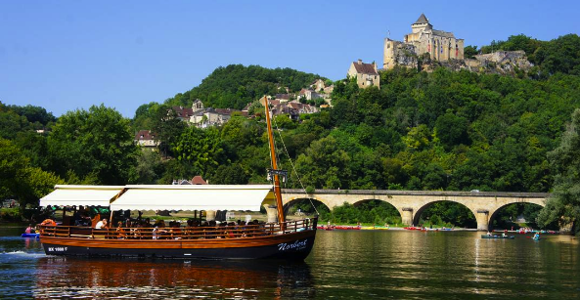

Guided Boat Tour – La Roque Gageac
La Roque-Gageac
The village of La Roque-Gageac is as old as it is mysterious. Humans have occupied this magnificent village built at the foot of the cliff, which is close to falling into the river, since prehistoric times. There are remnants of an ancient road and the site of a villa, from the Gallo-Roman era, as well as a Roman well in excellent condition. The known occupation of the site is however less distant. It dates back to around the year 849 with the arrival of the Normans in Périgord.

Ancient forts built into the cliff by locals to protect themselves remain from the time of the “Viking” invasions, when they came sailing up the Dordogne in their “drakkars” (Viking longships). Other remnants from this era include the wall and fortified houses, which made La Roque-Gageac a real fortress. This fortified town withstood the rivalries between the Capetians and the Plantagenets (French and English), only the gates anchored into the wall allowed entry into the village

Domme
Domme retains part of its original fortified walls and the gateways into the town. The ramparts are extremely thick and there remain three of the original doors. The Porte des Tours is perhaps the most impressive, with its round towers, but the Porte de la Combe and the Porte del Bos are both very pretty and accessible by walking down lovely streets lined with a mixed array of houses and cottages built from honey-colored stone distinctive to this region. The towers of the Porte des Tours were converted into prisons in 1307 when the king arrested the Knights Templers, and it is still possible to see the engraved crucifixes they carved whilst they were imprisoned. The prison is open throughout the year. We will have a guided visit of the village on a touristic little train before lunch and then we will continue on to Beynac.

Beynac
The pretty village of Beynac spreads along the northern bank of the Dordogne River, and up the hill behind, reaching the castle that stands poised above the village and river. The narrow lanes wind up through the traditional Dordogne white and yellow stone buildings. On the rivers edge you get some lovely views with the river, often full of canoes, a long stretch of wonderful stone houses and rising above the village the imposing chateau of Beynac. After our visit of the castle and the village, we will return to Sarlat for the night.

Day 5 – Friday, Sep 28th: Sarlat- Pech Merle- St. Cirq Lapopie- Cahors

Overnight in Cahors – Hotel La Chartreuse or similar (B)

Pech Merle Cave
Our day begins with a guided tour of authentic prehistoric paintings that are over 20,000 years old! Exceptional works of art including hundreds of representations of mammoths, bison, horses and aurochs are preserved on the walls at the Pech Merle cave. These figures are in their original natural setting and are a breathtaking site with a fascinating geological history.

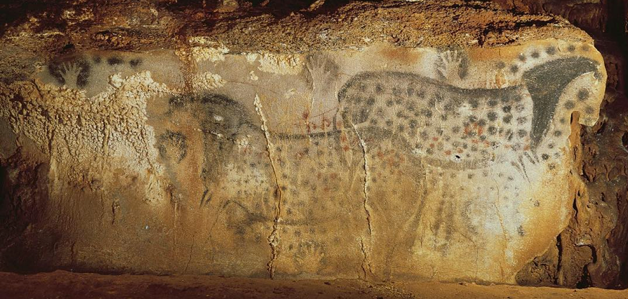

Peche Merle Cave

Saint Cirq Lapopie
After our guided tour of the Peche Merle Cave, we will continue our drive to Saint Cirq Lapopie for a visit of the village. This charming medieval town, with thirteen listed historic buildings, is one of the most spectacular villages in all of France. Perched on a cliff three hundred feet above the river Lot, it is considered one of the most important sites in the Lot Valley. The village was divided among several feudal dynasties in the Middle Ages whose dominant families were the Lapopies, the Gourdons and the Cardaillacs. As a result, several castles and fortified houses were built, each ever stronger, dominating the feudal village. In the streets, open arcades of shops preserve the memory of craft activities that created the wealth of St. Cirq. These custodians of ancestral practices are a delight to rediscover - potters, wood turners, ironworkers, carpenters, cabinetmakers, blacksmiths, stonemasons, jewelers, milliners, and embroiderers can all be found in their workshops or at nearby craft fairs. After our stroll through the town, we will continue to Cahors for the night.

Day 6 – Saturday, Sep 29th: Cahors

Overnight in Cahors – Hotel La Chartreuse or similar (B)

Today we will enjoy a wonderful guided city tour of Cahors and the Valentré Bridge. As one of the oldest wine producing areas of France, lush vineyards dot the area. After our city tour, we will continue to a local winery for wine tasting and a guided tour. The rest of the afternoon is free to explore Cahors.

Cahors
Cahors is strategically situated in a loop of the curvaceous river Lot, surrounded by hills. It was in this advantageous spot that the ancient tribe of the Cadurci decided to settle in about 800BC. The Romans, predictably, marched their legions over the land more than two thousand years ago, and it was they who planted the first vineyards in the first century AD. The heyday for this glorious old town came in the fourteenth century, when a local boy, Jacques Dueze, became Pope John XXII, and set up his seat at the papal palace in Avignon.

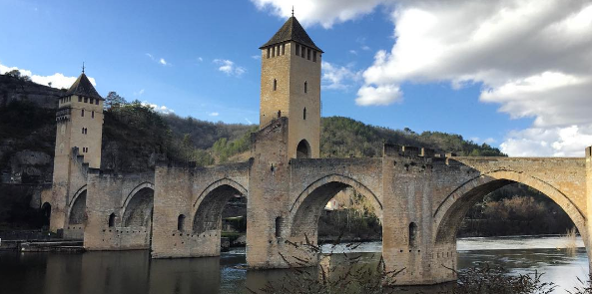
Valentré Bridge

The most famous landmark in the city of Cahors is the Valentré Bridge (Pont Valentré). Work began on the bridge over the River Lot in 1308 and its famous towers were built like a fortress so that the locals could defend invaders from above. The Valentré Bridge took some 70 years to complete and gave rise to a local legend involving a deal with the devil. It is also considered the most photographed landmark in France outside of Paris. Cahors really is an enchanting old town. With its ancient quarters and medieval bridge, cobbled streets, secret gardens and leafy boulevards, wonderful cafes, restaurants and relaxed street life. It has it all.

Day 7 – Sunday, Sep 30th: Rodez

Overnight in Rodez – Hostellerie de Fontanges or similar (B, L)

After breakfast and check out we will travel to the old city of Rodez and its 16th century cathedral. The cathedral is a superb illustration of architectural styles, ranging from Gothic to Renaissance and Classical. After lunch, we will visit the Pierre Soulages Museum. Then we will head to Marcillac for a guided tour of a winery and wine tasting.

Rodez
Rodez is a true gem hidden away in the rural, mountainous Aveyron department. The route there, and indeed the whole surrounding area, is countryside and hillsides. Then, Rodez is revealed with its small city verve. It features lovely cafes, quaint shopping, and eye-catching architecture. That's not to mention breathtaking, red sandstone Gothic cathedral that dominates the Old Town.

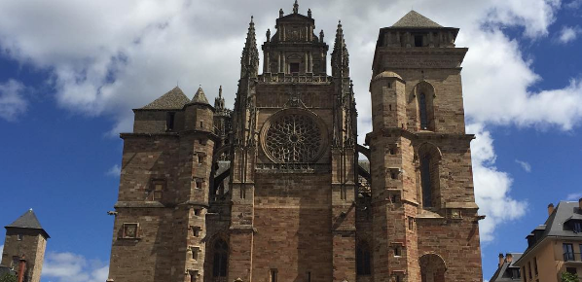
Rodez Cathedral

Pierre Soulages Museum
Rodez is also the birthplace of Pierre Soulages, a leading figure in abstract art and likely the most renowned French contemporary artist in the world. With exhibits in some 90 museums, he has created more than 1,500 works of art and held countless exhibitions around the world. The Pierre Soulages Museum holds paintings representing all of his work, from post-war oil paintings to his phase of work called Outrenoir. After our visit to Rodez we will continue our drive to Marcillac.

Marcillac
The monks of Conques first developed the vineyard of Marcillac more than 1000 years ago. It counts today about 500 acres of vineyards and fifteen points of production, with about fifty wine growers. Marcillac is isolated from the established winegrowing regions within France, but it is an up-and-coming area that is producing some increasingly respected wines. After our visit to the winery and wine tasting we will proceed to our accommodations in the Rodez area for the night.

Day 8 – Monday, Oct 1st: North Aveyron - Conques

Overnight in Rodez – Hostellerie de Fontanges or similar (B, L)

This morning we travel to Conques for a guided visit to the 10th century abbey. During the afternoon we will have a surprise excursion!

Conques
Conques has its origins, like many of the villages of France, in ancient pilgrim paths. A hermit called Dadon settled here in the 8th century, and soon attracted a group of Benedictine monks to his side. One of those 'obtained' the relics of Sainte Foy (pronounced 'fwa') from Agen and brought them to the monastery, where they soon attracted pilgrims due to their apparent ability to cure blindness. Conques was soon a major stop-off point on the pilgrim route to Santiago de Compostela.

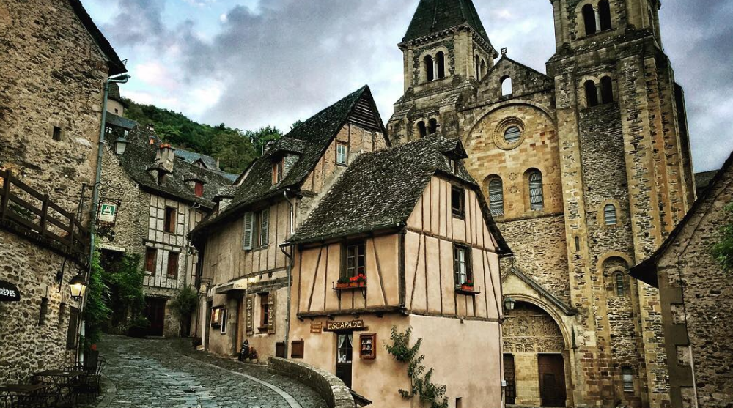
Conques

Conques Abbey was built in the 10th - 12th centuries, and the church and cloisters have an international and deserved reputation for their artistic merit. The tympanum (carved 'picture' above the main doorway) of the Last Judgment is considered to be one of the major art works of the 12th century. It really is incredible. There are 124 figures in the carvings many depicting your ghoulish fate if you are unlucky enough to go to hell. Surrounding the main carving are a few figures known as 'the curious ones' who look like little children peeking out from under a blanket at the scenes below.

Day 9 – Tuesday, Oct 2nd: South Aveyron - Millau – Roquefort

Overnight in Rodez – Hostellerie de Fontanges or similar (B, L)

Today we continue on to Roquefort for a guided tour of the famous cheese caves and cheese tasting. After lunch, we will enjoy a tour through “Les Gorges du Tarn”. The Tarn Gorges are dramatic gorges that follow the course of the Tarn River and are among the deepest gorges to be found anywhere in Europe. These extremely picturesque gorges offer several great vantage points from where to enjoy their beauty. After our tour of the area and the village of Millau, we will travel to St. Enimie before heading back to our accommodations in Rodez.

Roquefort
Roquefort is located in the Grands Causses Regional Natural Park and clings to the side of the Combalou Rock. Roquefort may seem peaceful, but it's also an industrial village; around a thousand people work to ripen the famous Roquefort cheese. Tradition dates back to a thousand years, and the secret is well kept at the depths of its natural caves.

Millau
Millau is a pretty little town nestled down in a valley with steep cliffs and impressive rock outcrops surrounding it on all sides. Now, of course, the spectacular bridge dominates many of the city views, imposing a somewhat surreal backdrop to Millau. The oldest part of the city is in and around the Place du Maréchal-Foch, which still retains some arcades from the medieval period.

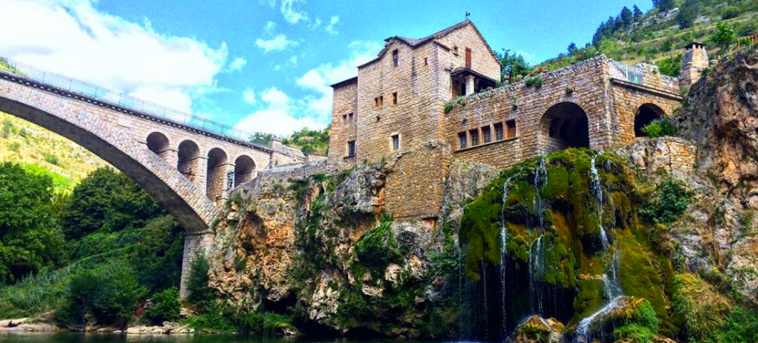

St. Enimie – Gorges du Tarn

St. Enimie
Sainte Enimie is an extraordinary medieval village of stonewalls and slate roofs tucked into a notch at the top of the gorgeous Tarn Gorges, a base for nature and river sports. The village is very compact, with the central part running down the hillside from the old monastery to the curved row of buildings across the bottom, lined with terrace cafés and restaurants and handy shops. The old village is all cobblestone streets, stonewalls, dark gray slate roofs and lovely little squares.

Day 10 – Wednesday, Oct 3rd: Albi - Carcassonne

Overnight in Carcassonne – Hotel Ibis Centre or similar (B)

Albi Cathedral
After breakfast, we will drive to Albi to see the historical 13th century Cathedral Basilica of Saint Cecilia. The cathedral stands prominently in the city of Albi and is believed to be one of the largest brick buildings in the world. With windows placed high up between the buttresses, entrances guarded by a moat, and extremely thick walls around the base to deter siege, the cathedral has the appearance of a fortress. The massive buttresses of the church have been compressed into the structure, functioning also as piers separating the chapels lining the nave, giving the Albi Cathedral a distinctive appearance from most Gothic cathedrals.

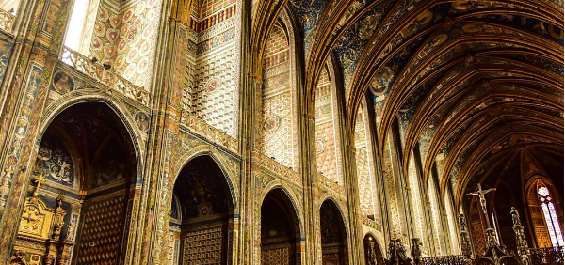

Albi Cathedral

On the UNESCO World Heritage list since 2010, the cathedral, palace and the nearby streets represent a unique ensemble of southern French Gothic architecture but with notable additions from elsewhere. For example, the decorative campaigns in the complex span the centuries and illustrate Catalan, Renaissance and Flemish styles that once flourished in the region.

Toulouse Lautrec Museum
After our visit of the cathedral, we will have a guided tour of the Toulouse Lautrec Museum that is dedicated mainly to the work of the painter Henri de Toulouse-Lautrec who was born near Albi. The museum houses over a thousand works by Toulouse-Lautrec, the largest collection in the world. Afterwards, we will proceed to Carcassonne for our accommodations for the night.

Day 11 – Thursday, Oct 4th: Carcassonne

Overnight in Carcassonne – Hotel Ibis Centre or similar (B, L)

This morning we begin with a guided tour of the magnificent fortified medieval town of Carcassonne. We will venture through the old town, the “remparts” and the Contal castle. After lunch, you may enjoy an optional guided cruise on the Canal du Midi crossing two locks.

Carcassonne
Boasting the longest city walls remaining in Europe, with battlements and ramparts dating to the 1st-century Romans, Carcassonne is the most impressive medieval town that we will visit. After admiring its fantastic walls, you may notice the overhanging wooden ramparts attached to the upper walls of the fortress that provided protection to defenders on the wall and allowed them to shoot arrows or drop projectiles on attackers beneath. Due to its position on historical routes across France the location has been occupied for more than 5,000 years. It was first fortified by the Romans, and given the name Carcaso. After the Romans were driven out, Carcassonne fell into the hands of various of the invading tribes, and became more fortified and developed, especially after being conquered by the powerful Viscount Trencavel.
Later, in the 13th century, the Albigensian Crusade under Simon de Montfort attacked and seized this Cathar stronghold, and again more fortifications were added, sufficient enough to keep Edward the Black Prince out of Carcassonne during the Hundred Years War. Subsequently the location and town gained strategic importance from being on the frontier between France and Spain. This became less important after 1659 when the Treaty of the Pyrenees passed the town and region definitively to France - hence from the 17th century onwards the need for fortified city passed and Carcassonne became an important regional town. The city reached its low point at the middle of the 19th century, when a century of abandon had made it perilously dangerous and the government demanded it be demolished. The buildings within the city were inhabited but in very poor condition. The efforts of the mayor and the ancient monuments inspector had this decision overturned and the restoration of the town began shortly afterwards by Viollet-le-Duc, one of the founders of the modern science of conservation.
Canal du Midi
This astounding 220-mile network of navigable waterways linking the Mediterranean and the Atlantic Ocean through 328 structures (locks, aqueducts, bridges, tunnels, etc.) is one of the most remarkable feats of civil engineering. Built between 1667 and 1694, it paved the way for the Industrial Revolution. The care that its creator, Pierre-Paul Riquet, took in the design and the way it blends with its surroundings turned a technical achievement into a work of art. This canal is defined by its beauty, lined with plane trees and crossed by pretty arched bridges. The Mediterranean weather and pace of life is relaxed and lulls you into unwinding as we meander gently downstream.

Day 12 – Friday, Oct 5th: Cathar Castles - Montpelier

Overnight in Montpelier - Mercure Montpelier or similar (B, L)

Today after breakfast we will explore two extraordinary Cathar castles; Lastours and Cucugnan. We will then head to Fontfroide for a guided tour of the abbey before proceeding to Montpelier for the night.

Cathars
The Cathars were a religious group who appeared in Europe in the 11th century, their origins are something of a mystery though there are reasons to believe their ideas came from Persia or the Byzantine Empire, by way of the Balkans and Northern Italy. Records from the Roman Catholic Church mention them under various names and in various places. Catholic theologians debated with themselves for centuries whether Cathars were Christian heretics or whether they were Christians at all. The question is apparently still open. Roman Catholics still refer to Cathar belief as "the Great Heresy" though the official Catholic position is that Catharism is not Christian at all.

The Cathar view of the Catholic Church was as bleak as the Catholic Church's view of the Cathar Church. On the Cathar side it manifested itself in ridiculing Catholic doctrine and practices, and characterizing the Catholic Church as the "Church of Wolves". Catholics accused Cathars of heresy or apostasy and said they belonged to the "Synagogue of Satan". The Catholic side created some striking propaganda. When the propaganda proved unsuccessful, there was only one option left - a crusade – the Albigensian Crusade.

The war against the Cathars of the Languedoc continued for two generations. In the later phases the Kings of France would take over as leaders of the crusade, which thus became a Royal Crusade. From 1208, a war of terror was waged against the indigenous population of the Languedoc and their rulers. During this period, an estimated half-million Languedoc men, women and children were massacred, Catholics as well as Cathars, as the Crusaders killed the locals indiscriminately.

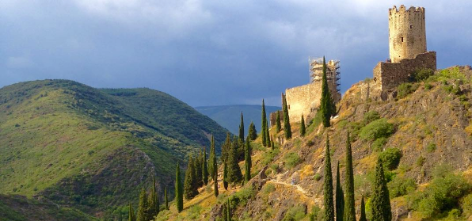

Castle at Lastours

Lastours
The first spot we will visit will be the four castles on a rocky spur above the village of Lastours. Isolated by the deep valleys of the Orbeil and Grésilhou rivers, the site belonged to the lords of Cabaret, mentioned for the first time in 1067 during the Middle Ages. Their wealth came mainly from the exploitation of iron mines. This is a fantastic destination for lovers of history and those interested in geology or Mediterranean fauna and flora. Archaeological excavations have been carried out around Cabaret Castle - where a village once stood - during the last two decades, exposing a large number of interesting 13th century relics. The houses in the village ran down the steep slope to the river, and were abandoned hastily during the Albigensian Crusade, explaining the large number of artifacts.

Cucugnan
We will then continue on to Cucugnan for a guided visit of the village and Queribus Castle. In the 13th century, during the Albigensian Crusade against the Cathars, the Lord of Cucugnan participated in the Cathar resistance before he was forced to submit to King Louis IX. In 1495, the Spanish invaders destroyed Cucugnan and a new village grew up around the ruined medieval site. The Château de Quéribus, which sits 1.3 miles southeast of Cucugnan, is a notable historical monument and is sometimes regarded as the last stronghold of the followers of the Cathar faith after their defeat at Montségur in 1244. Quéribus was originally built to defend the border between France and Aragon. After lunch, we will proceed to Fontfroide for a guided tour of the abbey.

Fontfroide Abbey
Surrounded by trees such as cypress, box tree and pine, this quiet abbey’s origins go back to the end of the 11th century. Having originally followed Benedictine rule, Fontfroide finally adopted the Cistercian order in the middle of the 12th century. As early as the beginning of the 13th century, Fontfroide had set up eight subsidiary abbeys. During the Crusade against the Albigensians, Fontfroide rose as a powerful stronghold of Catholic orthodoxy confronting the Cathar religion, which it fought against virulently. Two monks of Fontfroide stand out particularly at that time: Pierre de Castelnau and Raoul, who were appointed Papal Legates by Innocent III. After our visit we will head back to Montpelier for the night.

Day 13 – Saturday, Oct 6th: Montpelier

Overnight in Montpelier - Mercure Centre Comedie or similar (B)

Today we will have a full day to enjoy Montpelier with a guided tour of this wonderful city. We will spend time meandering throughout the historical center and visit the University of Montpelier; the oldest medical university in the world. The afternoon is free to see the rest of the city at your own pace.

Be sure to enjoy the many boulevards lined with shady trees, cafés, and antique stores including the large, car-free central square from the 1700’s. Some other notable sites include the 14th century Cathedral and a visit to the Musée Fabre with its vast collection of 17th, 18th, 19th and 20th century works (including an entire floor devoted to the gorgeous paintings of Pierre Soulages).

Montpelier
Montpelier is a true Southern France gem. Its attraction lies in its many inviting squares and their sidewalk cafes. It's been a great trading port for a thousand years and was an important university town in the 1500s. This is an urban center with a real buzz, rivaling Toulouse for the most exciting southern city. It has a delightful Old Town and a great university that adds to the unique cultural life. Leftist traditions have always been strong in Montpelier – the French national anthem, La Marseillaise, was born in the university here. Today, though, the city is keen to present its progressive and dynamic face – the latest Montpelier showpiece is a state of the art super tram network fit for the 21st Century which will even run out to the beach.

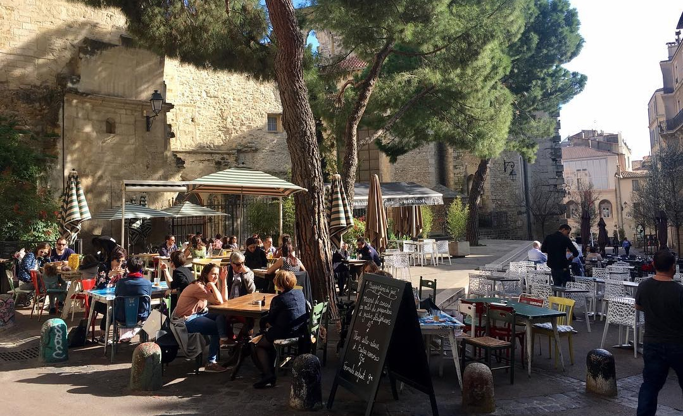
Montpelier

Day 14 – Sunday, Oct 7th: Paris

Overnight in Paris - Mercure Montmartre or similar (B)

Today we will take the AM Train á Grande Vitesse (High Speed Train) back to Paris. Enjoy the splendors of the "City of Lights" with a free afternoon and evening to see the sites.

Day 15 – Monday, Oct 8th: Paris - USA

After breakfast we will be taken to CDG airport for our return flight home at 11:35AM.

Hotels
Sarlat Hotel La Hoirie or similar
Cahors Hotel La Chartreuse or similar
Rodez Hostellerie de Fontanges or similar
Carcassonne Hotel Ibis Centre or similar
Montpelier Hotel Mercure Montpelier or similar
Paris Hotel Mercure Montmartre or similar

Cost of the Tour
Per person based on double occupancy (incl. international air) $6,320.00
Per person single occupancy: $6,995.00

NOTES:
- Price is subject to change due to currency exchange fluctuations or fuel surcharges
- It is possible that changes to the above itinerary may be necessary. If so, whatever is altered will be replaced by its equivalent

Included:
- International round trip air from Albuquerque to Paris
- All transportation within France by private chartered bus
- Local English speaking guides
- All entrance fees as per itinerary
- Porterage of one suitcase per person
- Meals as per itinerary: Breakfast (B) Lunches (L) Dinner (D)

Not included:
- Tips to hotel maids, guides or bus driver
- Drinks
- Items of personal nature

A deposit of $750.00 per person will be required to reserve your spot for this tour. Final payment is due on June 20th, 2018.

To sign up:
- Contact Rosa Carlson to check for available space.
- Fill out the Booking and Release Form, enclose your deposit check for $750.00 payable to Journeys International, Inc. (no credit cards) and attach a photocopy of your passport.
- Please mail everything to JOURNEYS INTERNATIONAL – 49 Verano Loop – Santa Fe NM 87508.

If you have any questions please call or text Rosa Carlson at Journeys International, Inc. at 505-310-1863 or email: carlsonrosa@hotmail.com

Cancellation Penalties

After deposit $200.00 administrative fee
After June 20th, 2018 100% percent of total tour price

Important: Purchase of trip cancellation insurance is strongly recommended. If you have any pre-existing conditions for which you would like coverage, most companies require that you must purchase the insurance within 14 days of your first payment for the tour. You can purchase coverage just for the amount of your deposit and later increase your coverage when the final payment is made. In addition, many health insurers, including Medicare, do not provide coverage for insured persons traveling abroad. Affordable health insurance for overseas travelers is readily available with companies such as Medex, Travel Guard, Allianz Travel Insurance and similar companies. Please contact Rosa Ramirez Carlson is you have any questions or need assistance in selecting insurance.

