JOURNEY TO COLOMBIA

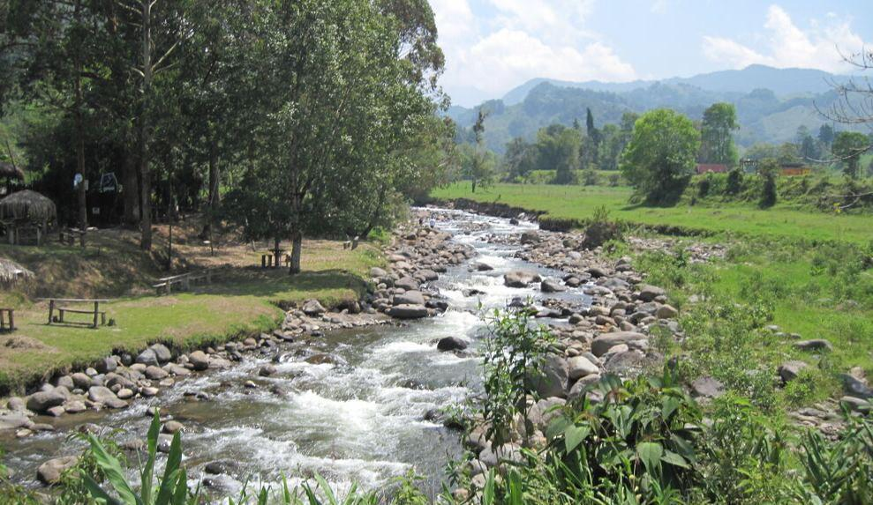

MARCH 17TH TO MARCH 31st, 2016

Colombia is truly a country like no other. Few countries encompass such beauty and diversity as Colombia, a land where rugged topography creates an elaborate variety of climates, vegetation, soils, crops and, of course, cultures. Colombia is the fourth-largest country in South America, and is unique in having both Pacific and Caribbean coasts.

Most of the country’s 45 million inhabitants are found in the central highlands. Journeys International will visit not only the larger cities of Bogotá, Medellín and Cartagena, but also smaller towns such as the charming Villa de Leyva and the quaint villages within Quindio, the Coffee Region.

Colombia continues to fight stigmas of past violence and drugs but the thoughts of "otherwise it would be paradise" are quickly diminishing, as Colombia is quickly becoming, quite simply, paradise. The warmth of the Colombian people and its fascinating culture might very well make Colombia your new favorite South American country. As a current hotspot for international travelers, you will be hard pressed to find even trace amounts of its previous self. From its darker past comes a much more relaxed, colorful and safer future. In fact, you will have a hard time finding a list of top new travel destinations that doesn't include Colombia.

Journeys International has scheduled this comprehensive 14-day tour to explore Colombia, highlighting the best it has to offer. Space is limited; please join us on this special adventure!

DAY-BY- DAY ITINERARY
BOGOTÁ
As the commercial center and country's capital, Bogotá is as lively and vibrant as you'll see in South America. This bustling city is home to a magnificent array of churches, museums, colonial mansions and government buildings. However, the real charm of the city lies in its diversity. Wherever you look, the mix between old and new is vibrantly displayed. The balance between its historical past and its stirring future makes the city a destination not to be missed.

Bogotá is now considered Colombia's largest political, financial and cultural center. With an elevation of 8,660 feet above sea level, this central Colombian city lies on the rim of a mountain plateau high in the Cordillera Oriental of the Andes but is still only 4°36' north of the equator. Founded on August 6th, 1538 by the Spanish conquistador Gonzalo Jiménez de Quesada, Bogotá became the vice-regal capital of New Granada in 1717. It was then captured by Simón Bolívar in 1819 and was the capital of Gran Colombia, an independent nation that later became three different countries: Ecuador, Venezuela and Nueva Granada. Nueva Granada was later named the United States of Colombia and in 1886 it was officially named the Republic of Colombia.

DAY 1 Thursday, March 17th - BOGOTÁ
Our departure from Albuquerque will be on United Airlines flight #3762 at 10.45am and arriving in Houston at 1.45pm. There we will connect to United Airlines flight # 1007 leaving Houston at 3.30pm and arriving in Bogotá at 8.45pm. Upon arrival and after clearing customs and immigrations we will be met and taken to our hotel.

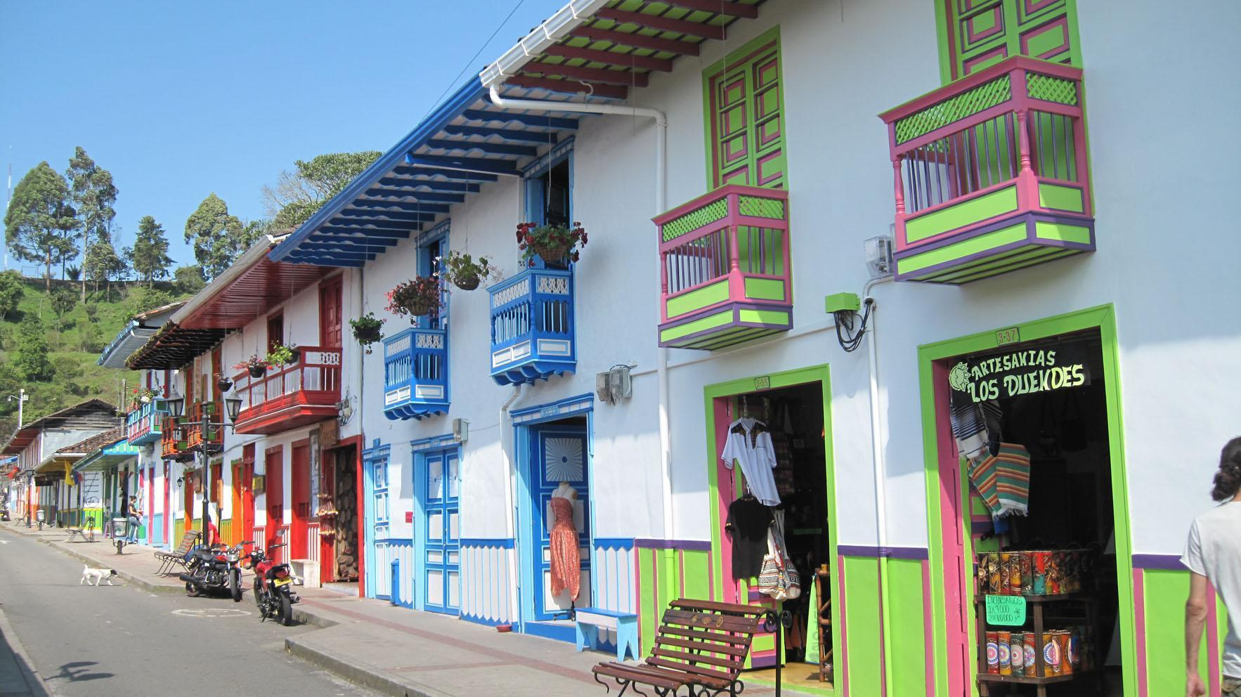

Day 2 Friday, March 18th - BOGOTÁ (B, L)
Our tour this morning begins at La Candelaria, the old historic center named after Nuestra Señora de La Candelaria. The district has retained much of its colonial atmosphere with cobblestone streets and centuries-old houses. Among the oldest educational establishments in the area is the Colegio Nacional de San Bartolomé founded by the Jesuits and operating continuously since 1604. We will visit Plaza Bolivar from where we will see the Corte Suprema de Justicia, the Catedral, the Alcaldia Mayor de Bogotá and the Capitolio.

Our tour continues at the Botero Museum. Situated in a renovated colonial house, the museum was opened in 2000 after Fernando Botero, Colombia’s most famous artist, donated 208 works, 123 of his own and 85 by other international artists. After lunch we will visit the Gold Museum, which houses the world’s largest collection of pre-Hispanic gold work, making it one of Colombia’s most historically important museums. The objects on display tell us about the social make up of the regional pre-Columbian cultures. Some of these were organized into rather strict caste systems. Some dignitaries were cast in gold as half-human, half-animals because they were viewed as descendants of gods, relating to powerful animals like jaguars. The museum’s masterpiece is probably the “Muisca raft” which is displayed in its own room towards the end of the exhibition. This incredible, golden sculpture portrays a chief, his priests and six oarsmen sailing in a raft. A group of peasants discovered this incredible object in a cave south of Bogotá in 1856 and it has been dated to between 1200-1500BCE.
VILLA DE LEYVA
Villa de Leyva draws numerous and delightful comparisons to the wonderful region of Andalucía, Spain. The qualities are very similar with wooden doors and windows, white facades and Moorish balconies that will remind you of the Hispanic tradition of the town. Villa de Leyva was founded in 1572 and built in accordance with typical Spanish architectural standards. The location itself – within a valley – may have even brought an emotional equivalency in the New World to similar sites throughout Spain. The true character and beauty of Villa de Leyva lies within this valley.

Day 3 Saturday, March 19th - VILLA DE LEYVA (B, L)
We leave Bogotá and travel across a high Andean plateau through countryside once inhabited by the native Muisca Indians. In this region, where salt deposits have been mined since pre-Colombian times, we will stop in the town of Ipaquira and walk deep into the ground as we venture into the Salt Cathedral. The Salt Cathedral is renowned for its magnificent architectural and artistic style.

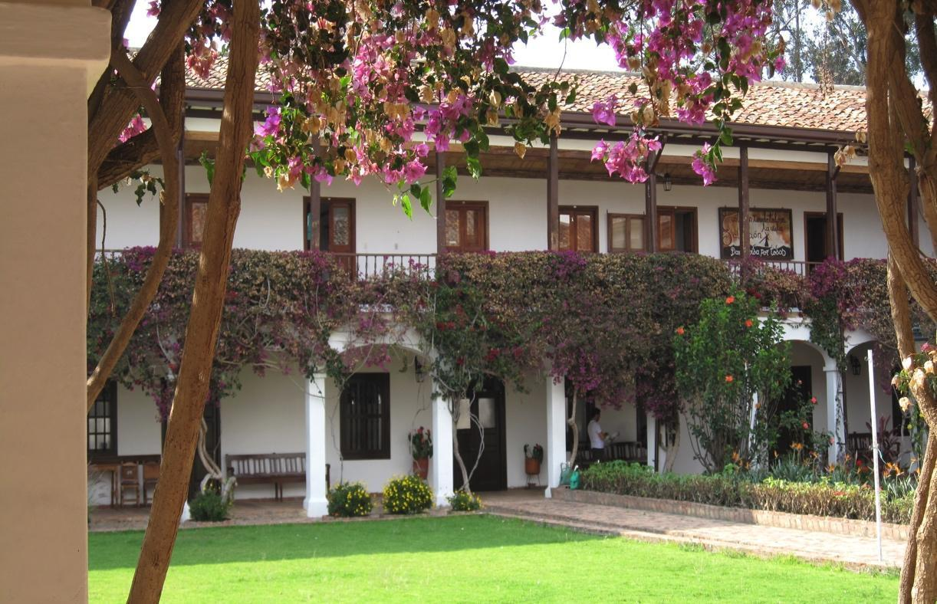

Throughout the town square in Zipaquirá we will find beautiful buildings that have preserved their colonial style, and are considered to be national monuments. Our tour continues on through the splendor and expanse of the Bogotá Sabana to our lunch destination. After arriving in Villa de Leyva and checking into our hotel, we will have a brief walking tour of the town center.

Day 4 Sunday, March 20th - VILLA DE LEYVA (B)
Our full day excursion from Villa de Leyva includes a visit to several surrounding villages including Ráquira, a pottery-making village since pre-Columbian times and still considered a center of ceramic production. There are dozens of craft shops around the main square and several where you can watch pottery being made. Just 7 kilometers (4.3 miles) past Ráquira is the town of La Candelaria and the Monasterio de La Candelaria, founded in 1597 by Augustine monks, where you can visit the chapel and its 16th-century painting of La Virgen de la Candelaria, a small museum, the library and the courtyard flanked by 17th century canvases. We end this trip at Sutamarchán, where people come from hundreds of miles away to taste their famous pork sausages.

Day 5 Monday, March 21st - VILLA DE LEYVA (B)
You can spend the day enjoying your surroundings. We encourage you to have a late breakfast and then go meandering through this picturesque town. For our more active travelers, we recommend a hike to nearby areas.
THE COFFEE REGION
With seemingly endless spectacular panoramas behind every turn along with rolling hillsides, abundant coffee plantations, plunging valleys and audacious elevations, it becomes obvious why many people consider the coffee region of Colombia the cultural epicenter and the heart and soul of the country.

Campesino, or rural life, continues as it has for centuries, harvesting coffee, plantains and various other fruits in this rich and fertile land. A visit to the coffee region warrants you to experience the tranquility of the region. Three departments make up the Triangulo Del Café. These three run in a North to South line following the Central Andean Cordillera. Caldas is the most northerly of the three, heading south to Risaralda and finally Quindío. The scaling snowcapped peaks of the Parque Natural Los Nevados to the East flank all three departments.

The climate is reflected by the extremes in altitude, from the harsh temperatures and savage beauty of the surrounding mountains at 5,000 meters above sea level (16,400 feet), to the sultriness of the Rio Cauca, the largest waterway in the region and also the second most important in Colombia. The river begins in the department of Cauca and merges with the Rio Brazo and then merging further with Rio Magdalena to the north. Although the region is famous for its Colombian coffee, this beautiful part of Colombia has so much more to offer.

Day 6 Tuesday, March 22nd - QUIMBAYA (B, D)
After breakfast and check out we will depart our hotel for the three-hour journey back to Bogotá. We will be taken to the airport for our domestic flight to Pereira. Our Avianca Airlines flight #8503 departs Bogotá at 2.19pm and arrives in Pereira at 3.19pm. Upon arrival in Pereira we will be taken to our hotel.

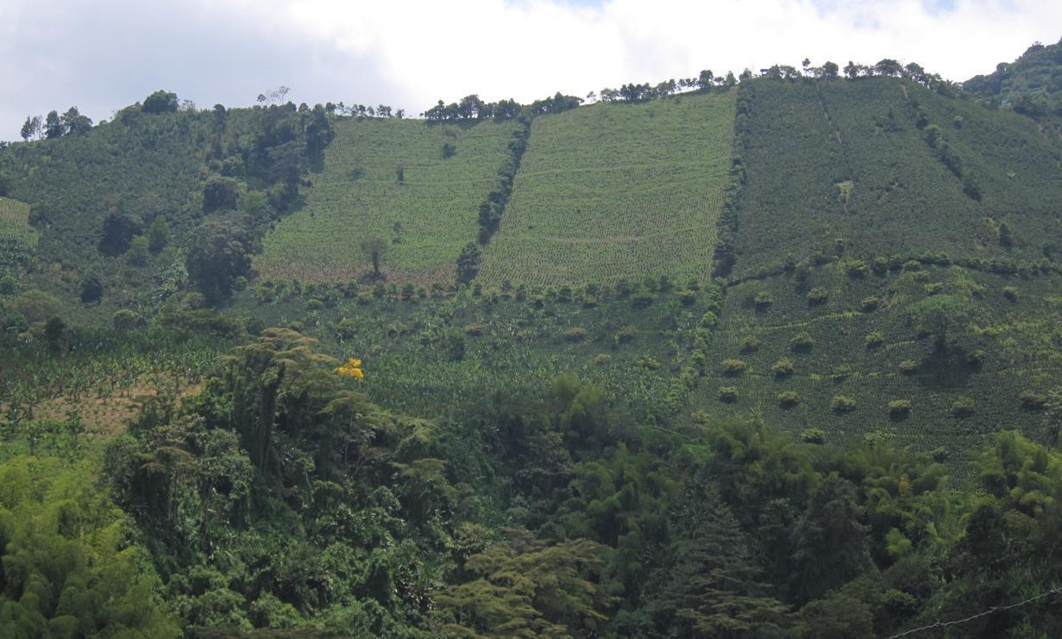

Day 7 Wednesday, March 23rd - QUIMBAYA (B, L, D)
Our exploration today covers a region enveloped in the stunning natural beauty of the Cocora Valley. As we enter into Filandia, the character and architecture that has withstood generations shows us that we are in the heart of the Colombian coffee region. The town square has not changed in decades and the historical buildings, landscapes and welcoming locals makes Filandia one of the most beautiful and attractive towns in Colombia. From Filandia we will drive through the picturesque Cocora Valley, a sanctuary for the Wax Palm tree, the tallest palm tree in the world and recognized as the national tree of Colombia; it is also a threatened species.
We will continue on to Salento, a municipality in the northeastern area of the Quindío Department. This was the first modern settlement in Quindío, dating back to 1850. Offering a very traditional and rural appeal, Salento is a picturesque town surrounded by distant snowcapped mountains and spotted with various traditional houses of the original architectural style. For our more active participants, we will walk to a viewpoint that overlooks Salento on one side and the Cocora Valley on the other.

Day 8 Thursday, March 24th - QUIMBAYA (B, D)
With the support of Colombia Coffee Growers Association, UNESCO has recognized the region as a Colombia Coffee Cultural Landscape: an example of human adaptation to challenging geographical locations creating a landscape where the natural, cultural and economic features merge. People of coffee country are proud of this recognition. This journey will surround us with hills covered by lush green coffee, yucca and plantain fields. As you begin to appreciate this enchanting region, you’ll see the “campesinos” pass by on their way to the fields and begin to imagine what life is like for these rural populations. Today we will immerse ourselves into a very personal and up close experience in the heart of the world’s Coffee Belt. We will learn about the coffee plantations and see the process of coffee production, from seedling to coffee cup.

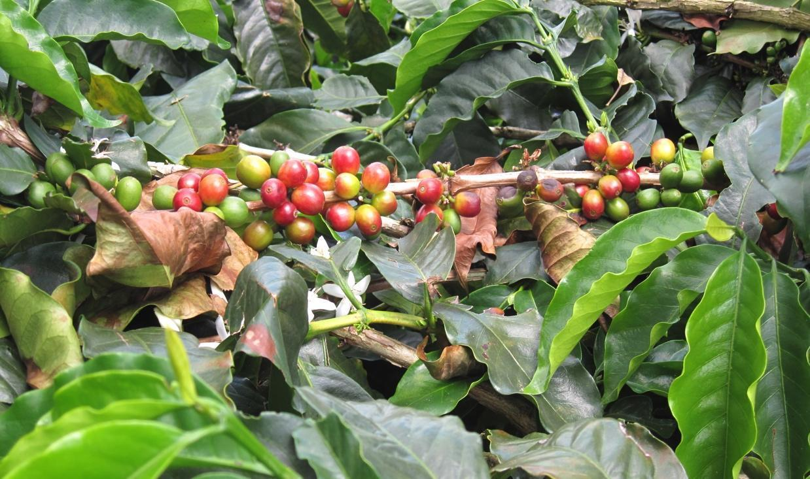

You’ll never look at coffee the same way again as you understand the hardships that the region’s coffee growers face and how this simple bean can affect their entire way of life. That delicious roast has a history where entire regions of people are planting, picking, toasting and tasting to bring you the magic “elixir of life” from this beautiful region of Colombia.
MEDELLíN
Quickly becoming the third most popular city with tourists in Colombia (after Cartagena and Bogotá),
Medellín feels like a city twice its size. Situated in a narrow valley, the city’s skyline reaches up against a backdrop of jagged peaks in every direction. The wonderful climate gives the city its nickname “the City of Eternal Spring”. Medellín, Colombia’s second largest city has in the past 20 years transformed into a leader in developing a more inclusive, sustainable and creative place to live.

The city has come together, planned and more importantly, implemented projects using social urbanism, city branding and informal settlements. With a renowned leadership in finance, banking, services, politics, art, culture, communications, fashion, and entertainment industries, the city is a true developmental axis. The people from this region of the country, or the “paisas”, have earned a reputation as resourceful visionaries. Although Medellín has had to deal with a tarnished reputation for years it has now succeeded in becoming in one of the most up-and-coming destinations in South America and even regarded as one of its safest.

Day 9 Friday, March 25th - MEDELLÍN (B, L)
This full day journey (6 to 8 hours) will take us through some of the most spectacular scenery in Colombia and give us the opportunity see parts of the country that visitors rarely get to experience. As you descend from the undulating hills of the Coffee Region to the valley of the Rio Cauca, the country’s second longest river, we will travel through small villages and fertile farmland before the road winds its way through the river valley and gorges to the small town and river crossing at La Pintada. From here we ascend the winding mountain road passing by orange plantations and small coffee farms before the final descent to the Aburra Valley and Medellín, the city of eternal spring. Along the way we will have lunch at one of the many excellent roadside restaurants, “estaderos”, serving simple but delicious food, prepared from local ingredients.

Day 10 Saturday, March 26th - MEDELLÍN (B, L)
A tour within the central area of Medellín will show why Medellín is so important to Colombia in terms of both culture and commerce. The tour will take in many of the principal sites and locations of this fascinating city. A ride on the city’s famous metro system will not only provide great views of the city but will be a unique chance to understand the geography and social make up of Colombia’s second largest city. We pass through the barrio of Santo Domingo, which once suffered from appalling levels of violence but which now has been transformed through transport, education and art projects. Line L of the metro, an aerial cable car, extends from Santo Domingo station to Parque Arvi, inaugurated in 2009. The ride from Santo Domingo to Parque Arvi takes 20 minutes over hillsides and forests and the views are spectacular. After a walk in the park, our bus will pick us up and take us to a local restaurant for lunch. In the afternoon we will visit the Parque Berrio, where we will see some spectacular sculptures by Fernando Botero, and the Museum of Antioquia before returning to our hotel. The rest of the day is free for further exploration.
CARTAGENA DE INDIAS
Founded in 1533 by Pedro de Heredia, Cartagena was formerly the Caribbean gateway port used by the Spanish. Here they would store the riches plundered from the interior before transporting them to Spain. It is not surprising therefore that the city was a draw for buccaneers and pirates who attempted on many occasions to take the city, most notably by Sir Francis Drake in 1586 who "mercifully" agreed not to level the city in return for 10 million pesos that he carted back to England. It was after the attack by Drake that plans were made to fortify the city and work on the defensive walls began. These walls still stand today and mark the boundary between the old and new parts of the city. The walls and fort took a total of 200 years to build. The Spanish completed the walls just 25 years before the country gained its independence. Cartagena ultimately won its Independence in 1821; a full 3 years after Bogotá had been liberated. Cartagena's fascinating history, abundant energy and diverse culture absorb countless visitors each day as they are given a hint into the past and a chance to relax in its magnificent surroundings. This vibrantly diverse and passionate city hosts some of the best-preserved colonial architecture in South America. You will be amazed by the character that Cartagena projects, mixing the colonial Spanish grandeur with pulsating African rhythms and traditional indigenous influences. Simply put you will love what Cartagena has to offer!

Day 11 Sunday, March 27th - CARTAGENA (B)
Today we travel from Medellin to the fascinating port of Cartagena, a name that conjures defensive walls, color, music, riches and pirates. We will take a meandering walk through some of its cobbled stone streets and courtyards before enjoying a sunset drink (on your own).

Day 12 Monday, March 28th - CARTAGENA (B L)
Our tour will begin as we walk through the old town under the Puerta Del Reloj, a symbol of Cartagena, into the Plaza de los Coches. We continue from the Plaza San Pedro Claver with its stunning church, on through to the Plaza Bolivar; with its shady areas, where a fresh lemon juice can be enjoyed while watching the world go by. Later we will continue to Castillo San Felipe. This impressive fort is the largest Spanish fortification in the Americas and dominates the old town. Finally we will visit the Convent of La Popa, a 150 meter-high (490 feet) hill that is the highest point in the city. Its name literally translates to the Convent of the Stern, after the hill's apparent similarity to a ship's stern. Its official name is actually Convento de Nuestra Señora de la Candelaria. A beautiful image of La Virgen de la Candelaria, the patroness of the city, can be found in the convent's chapel, alongside a charming flower-filled patio. There is also a statue of a martyred Padre Alonso García de Paredes, a priest who was murdered along with five Spanish soldiers for trying to spread Catholicism. This is a perfect spot for outstanding views of the entire city.

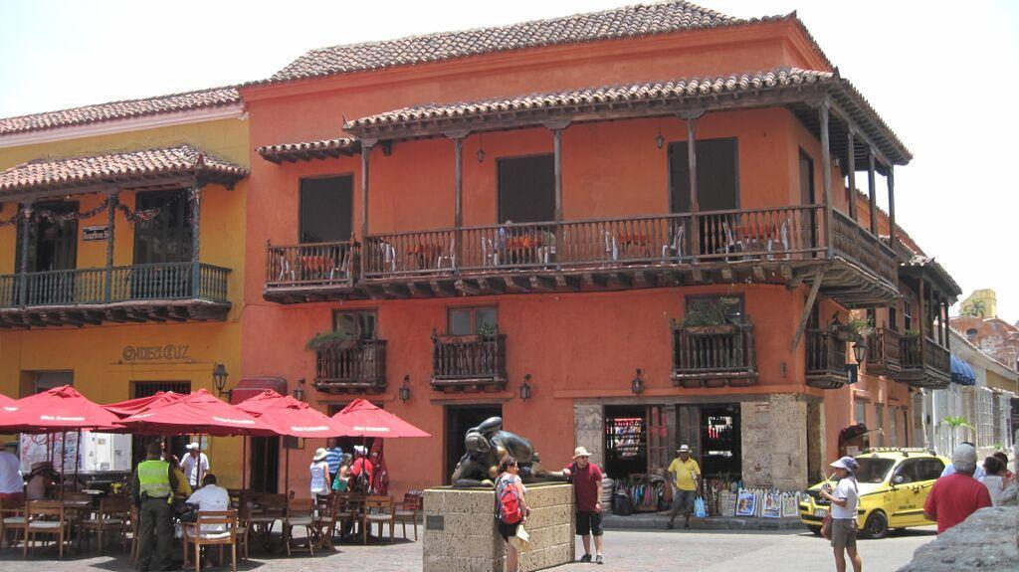

Day 13 Tuesday, March 29th - CARTAGENA (B)
Cartagena de Indias is a fairy-tale city of legends, romance and absolute beauty. With its delicate historical buildings, beautiful colors and buoyant people, it is a city that can become addictive and a rather hard place to leave behind. This is a place where all sightseeing routines must be abandoned in place of a simple stroll through Cartagena’s cobbled alleyways. With towering churches, leafy plazas, enormous Moorish balconies, and a prohibition of most vehicles, there is an abundance of ease to be had. Relax and take time to visit one of Cartagena’s many open-air cafés, a prime spot to view the spectacle of horse-drawn carriages, stylish locals and bustling tourists.

Day 14 Wednesday, March 30th – International Departure
After breakfast and a leisure morning, we will be taken to the airport for our flight to Bogotá. We will depart on Avianca Airlines flight #9551 leaving Cartagena at 7.50pm and arriving in Bogotá at 9.20pm.
There we will wait for our international connection on United Airlines flight #1006 leaving at 12.14am.

Day 15 Thursday, March 31st – Arrival USA
Our arrival in Houston will be at 5:34am. After clearing customs and immigrations and going through security we will board United Airlines flight #3544 leaving Houston at 9:10am and arriving in Albuquerque at 10:07am.
Welcome home!!

HOTELS
Bogotá Hotel Morrison or similar
Villa de Leyva Hotel La Posada de San Antonio or similar
Medellín Hotel Sites or similar
Quimbaya Hotel Casa de los Nogales or similar
Cartagena Hotel Don Pedro de Heredia or similar

Price per person based on double occupancy $4,625.00
Single supplement $875.00

INCLUDED:
Round trip airfare on United Airlines from Albuquerque
(Note: Airfare from other departure cities will be adjusted according to actual cost)
3 domestic flights on Avianca Airlines within Colombia
All accommodations and transportation in charter bus
All entrance fees and English-speaking guides for all the tours
All meals as described on the itinerary
Tips for porters, bus driver and guides

NOT INCLUDED: Items of personal nature.

REGISTRATION AND PAYMENTS:
To register for this tour, please print and fill out our Booking & Release Form
Please return to us with a copy of your passport.
A deposit of $500 per person will be required at the time of booking.
Please send the required documentation and check to:

Journeys International, Inc.
49 Verano Loop
Santa Fe NM 87508

You can also email the Booking & Release Form along with your copy of your passport to:

info@journeys-international.com

Final payment is due on December 1st, 2015.

For any questions or comments please contact Rosa Ramirez Carlson at the following email address:

info@journeys-international.com

In case of cancellations, the following penalties will be applicable:
After deposit $150.00 administrative fee
After December 2nd, 2015 100% of the total tour price

Important: Purchase of trip cancellation insurance is strongly recommended. If you have any pre-existing conditions for which you would like coverage, most companies require that you must purchase the insurance within 14 days of your first payment for the tour. You can purchase coverage just for the amount of your deposit and later increase your coverage when the final payment is made. In addition, many health insurers, including Medicare, do not provide coverage for insured persons traveling abroad. Affordable health insurance for overseas travelers is readily available with companies such as Medex, Travel Guard, Allianz Travel Insurance and similar companies. Please contact Rosa Ramirez Carlson is you have any questions or need assistance in selecting insurance.

