Discovering Scotland

Journeys International, Inc.

& Rosa Ramírez Carlson

June 5th – June 19th, 2018

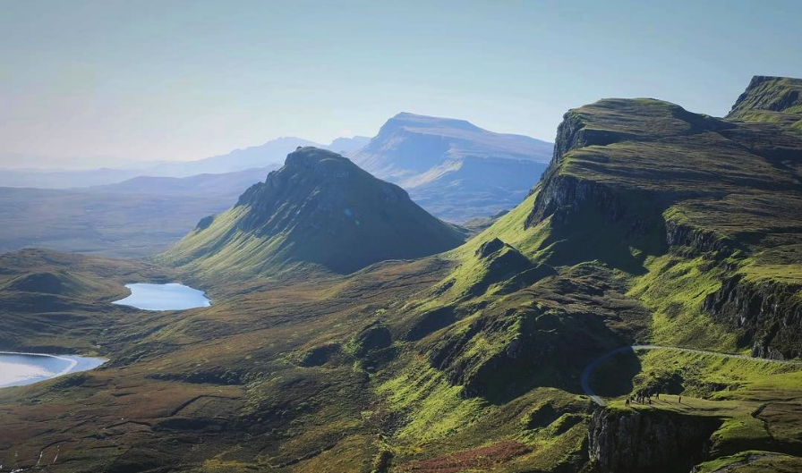

We are delighted to take you on a fascinating tour of Scotland!

If Scotland has been on your list, this wonderful trip will leave nothing to be desired! Join us as we step back in time through the historical medieval towns of Edinburgh and Stirling, take the Jacobite Steam Train through The Highlands, relax at the fairy pools on the Isle of Skye, tour one of the most iconic images of Scotland at Eilean Donan Castle, relax and enjoy the fantastic scenery along the bank of the River Ness at Inverness, tour the famous Scottish battlefield of Culloden and the ancient cemetery at Clava Cairns, enjoy the history amongst the ruins of Beauly Priory, Inchmahome Priory and Elgin Cathedral, visit the picturesque Victorian village of Ballater in Cairngorm National Park, spend an afternoon sipping Scotch on a whisky tour, enjoy a round of golf at one of the many historic golf courses at St. Andrew’s, touch up on Scotish history at Dumferline Abbey and Falkland Palace and taste Scotland’s best fish and chips in the small fishing village of Anstruther.

Journeys International has scheduled this comprehensive 14-day tour to explore the wonderful treasures Scotland has to offer! Space is limited; please join us on this very special adventure!

Day 1: June 5th Depart NYC, John F. Kennedy Airport – Overnight Flight

Day 2: June 6th Edinburgh

Overnight in Hotel Parliament or similar (B, D)

Welcome to Scotland! After your overnight flight, we will leisurely explore the city, taking in the sights and sounds as we overcome our jet lag. Light dinner included.

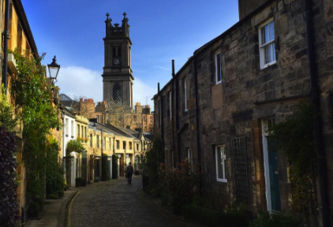
The streets of Edinburgh

Day 3: June 7th Edinburgh

Overnight at Hotel Parliament or similar (B)

Our day starts with a half day tour of Edinburgh including the famous Edinburgh Castle, stroll along the iconic Royal Mile and Holyrood Park and enjoy the spectacular views and monuments at Calton Hill, a UNESCO World Heritage Site.

Edinburgh
Bursting with historical attractions, Edinburgh is the capital of Scotland and is a truly enthralling city. Offering an eclectic mix of ancient and modern, the city’s sights are easy to experience and enjoy in a uniquely Scottish atmosphere. Lying on the west coast of Scotland’s east Lowlands, humans have inhabited Edinburgh for millennia, as early as 8500 BC, 5,000 years before the Bronze Age. It is named after the English first invaded its fort and claimed it “Eiden’s Burgh” where “Burgh” is another word for fort. The Scots reclaimed it a few centuries later and a castle was built. However, the Scots would lose and reclaim the city many times over the years. Including a famous battle from William Wallace made famous by the movie Braveheart.

Day 4: June 8th Stirling

Overnight at Highland Hotel or similar (B)

Today we will head to the historic city of Stirling to learn and admire the country’s rich heritage. There’s really no better place to learn about Scotland’s bloody history than the city of Stirling.

Stirling
Also known as “The Gateway to the Highlands” Stirling used to be the only connection to the Highlands giving it a significant position in Scotland’s history. The magnificently situated, and well-conserved castle stands atop volcanic rock that made it the key to holding Scotland during the Wars of Independence. A significant core of the medieval and Renaissance buildings of this royal “burgh” remain. The Stirling Castle is likely Scotland’s most interesting but we will explore other aspects of Scottish history at both the National Wallace Monument, which commemorates William Wallace, and at the Bannockburn Heritage Centre, close to the site of a significant battle in 1314. The battle all but guaranteed Scotland’s survival, and has been comprehensively revamped for the battle’s 700th anniversary.

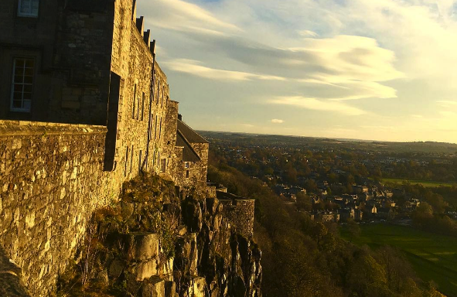
View from Stirling Castle

Day 5: June 9th Stirling

Overnight at Highland Hotel or similar (B)

Today we will have a half day tour of the city with enough time to explore and discover Stirling on your own. This afternoon you can leisurely stroll through the many historical sites, museums and parks or do some shopping in the numerous independent boutiques in the historic Old Town and Victorian Stirling Arcade.

Day 6: June 10th Fort William

Overnight at Clan Macduff or similar (B, L)

Our morning departure will take us to Fort William. Along the way, we will stop at the picturesque island and monastic sanctuary at Inchmahome Priory and lunch at the famous, 300-year-old Drovers Inn before a free evening in Fort William.

Inchmahome Priory
Cross Scotland’s only lake to explore a peaceful, wooded island chosen as a monastic sanctuary. Robert the Bruce sought solace at Inchmahome Priory and Mary Queen of Scots found safety here as a child. Walter Comyn founded the priory for Augustinian canons around 1238. Much later, long after monastic life had ended, Sir Walter Scott revived the island’s popularity. His Romantic novels and a new railway brought tourists flocking to the area in the 1800s.

Drovers Inn
The Drovers Inn Hotel, Inverarnan near Loch lomond is probably the most famous inn and pub in Scotland. This 300-year-old inn offers great historical atmosphere and good Scottish food and is a must for anyone visiting Loch Lomond or traveling through.

Day 7: June 11th Jacobite Train Fort William - Mallaig – Portree (Isle of Skye)
We board our morning train from Fort William at 10:15am and arrive in Mallaig at 12:25pm. Overnight at Cuillins Hills Hotel or similar (B, D)

Jacobite Steam Train
All aboard! This morning we embark on a truly unforgettable journey onboard the Jacobite Steam Train for a one-way ride to Mallaig, a small fishing village on Scotland’s Western Coast. The train portrayed as the Hogwarts Express in the Harry Potter Films is actually this vintage steam train. This is one of the world's great train journeys and will take you past Britain's highest mountain, deepest loch, shortest river and most westerly station.

You'll cross the viaduct featured in the Harry Potter films and pass the Glenfinnan Monument where Bonnie Prince Charlie raised his standard at the beginning of the 1745 Jacobite rising. After we land in Mallaig we will stop for lunch (on your own) before making our way to our accommodations on the Isle of Skye.
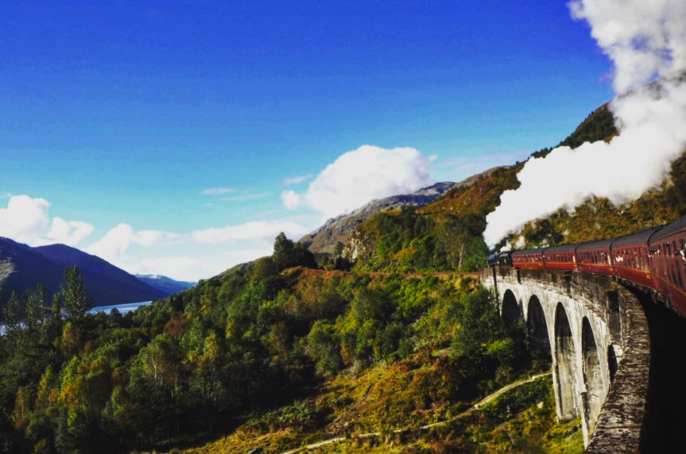
Jacobite Steam Train

Day 8: June 12th, Isle of Skye
FD tour of Skye - overnight at Cuillins Hills Hotel or similar (B, L)

Today our full day tour will include stops to grasp and take in the beautiful scenery and the many sights that Skye has to offer. We will tour the fairy pools, the lighthouse at Neist point, Dunvegan Castle and gardens - the oldest continuously inhabited castle in Scotland, the magical scenery at Faerie Glens before stopping at the Flodigarry Hotel for lunch with an incredible view. We will head back after lunch with photo stops at the Quiraing, the Kilt rock and the Old Man of Storr.

Skye
The Isle of Skye (an t-Eilean Sgiathanach in Gaelic) takes its name from the old Norse sky-a, meaning ‘cloud island’, a Viking reference to the often-mist-enshrouded Cuillin Hills, the rocky slopes of which provide some of the most dramatic mountain scenery in the country. It’s the 2nd largest of Scotland’s islands, a 50-mile-long patchwork of velvet moors, jagged mountains, sparkling lochs and towering sea cliffs. The stunning scenery is the main attraction, but when the mist closes in there are plenty of castles, crofting museums and cozy pubs and restaurants; there are also dozens of art galleries and craft studios.

Along with Edinburgh and Loch Ness, Skye is one of Scotland’s top-three tourist destinations. However, the crowds tend to stick to Portree, Dunvegan and Trotternish – it’s almost always possible to find peace and quiet in the island’s further-flung corners. Come prepared for changeable weather: when it’s fine it’s very fine indeed, but all too often it isn’t.

Fairy Pools
At foot of the Black Cuillins are the Fairy Pools, beautifully crystal clear blue pools on the River Brittle. These famous pools entice visitors from all over the world, as they make some great ‘wild swimming’ for those brave enough to enter the cold water. For the less adventurous these magical Fairy Pools make some fantastic photos.

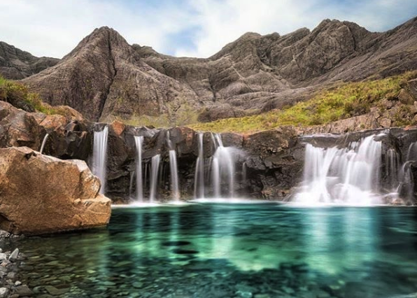
Fairy Pools – Isle of Skye

Neist Point
Neist Point is one of the most famous lighthouses in Scotland. While the walk down is an easy one, the concrete path does get quite steep at times. From the path you will see stunning views of the high cliffs and the lighthouse itself, at sunset the view is made even more spectacular making this a top destination for landscape photographers.

Denvegan Castle & Gardens
Built on a rock in an idyllic loch side setting, Dunvegan is the oldest continuously inhabited castle in Scotland and has been the ancestral home of the Chiefs of Clan MacLeod for 800 years. On display are many fine oil paintings and clan treasures, the most famous of which is the Fairy Flag. Legend has it that this sacred banner has miraculous powers and when unfurled in battle, the clan MacLeod would invariably defeat their enemies. Another of the castle's great treasures is the Dunvegan Cup, a unique 'mazer' dating back to the Middle Ages. The O’Neils of Ulster gifted it as a token of thanks to one of our most celebrated Chiefs, Sir Rory Mor, for his support of their cause against the marauding forces of Queen Elizabeth I of England in 1595.

Fairy Glen
The road to “Faerie” Glen winds around small round-topped grassy hills with lochans (ponds) in between which gives the glen an otherworldly feel. Skye has a long history involving the fairies (Faerie), most of which is related to Dunvegan Castle and their ‘Fairy Flag’. Although the Fairy Glen (much like the Fairy Pools in Glenbrittle) does not have any legends or stories involving fairies, it is easy to enjoy and appreciate its magical essence.

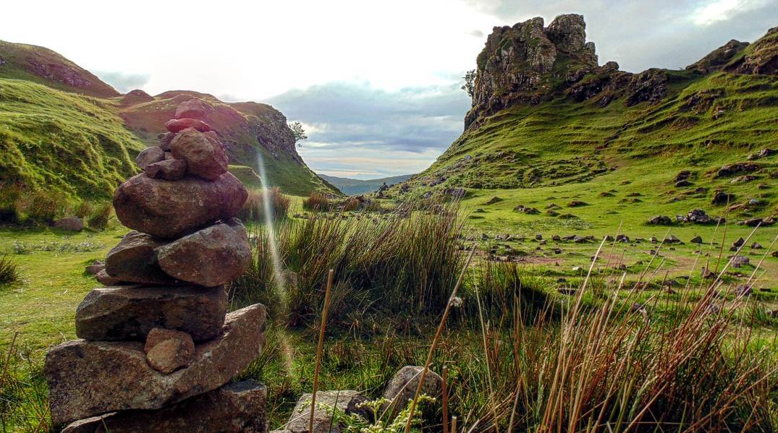
Fairy Glen

Old Man of Storr
The ‘Old Man’ is a large pinnacle of rock that stands high and can be seen for miles around. As part of the Trotternish ridge the Storr was created by a massive ancient landside, leaving one of the most photographed landscapes in the world.

Day 9, June 13th: Eilean Donan Castle – Loch Ness – Urquhart Castle – Inverness
Overnight at Best Western Palace Hotel or similar (B, L)

Our journey today will depart Skye and head towards Inverness with stops at one of the most famously photographed Eilean Donan Castle, the famous Loch Ness and Urquhart Castle.

Eilean Donan Castle
Eilean Donan Castle is one of the most recognized castles in Scotland, and probably appears on more shortbread tins and calendars than any other. It is, without doubt, a Scottish icon and certainly one of the most popular visitor attractions in the Highlands. When you first set eyes on it, it is easy to understand why so many people flock to its stout doors year after year. Strategically located on its own little island, overlooking the Isle of Skye, at the point where three great sea-lochs meet, and surrounded by the majestic splendor of the forested mountains of Kintail, Eilean Donan’s setting is truly breath-taking.

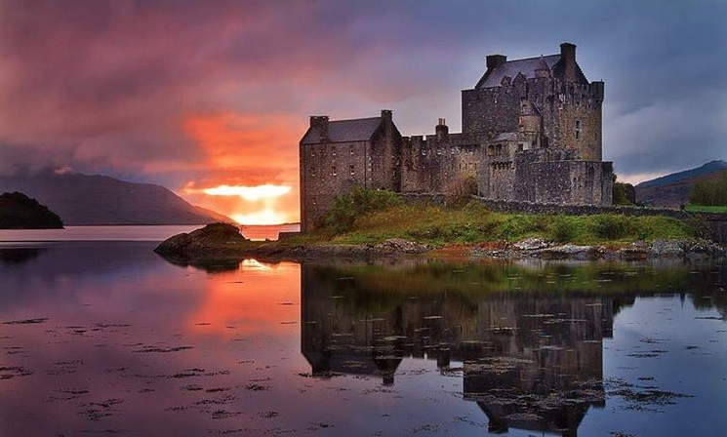
Eilean Donan Castle

Loch Ness
Loch Ness is one of Scotland’s largest and most famous lochs, known around the world thanks to its elusive monster Nessie. Just a short distance from Inverness, this impressive stretch of water is 23 miles long and over 700 ft. at its deepest, making it Scotland’s largest loch in terms of volume. Loch Ness runs from Loch Dochfour to Fort Augustus, with picturesque villages such as Foyers and Dores bordering it.

Urquhart Castle
Discover 1,000 years of drama, experience a glimpse of medieval life and enjoy stunning views over Loch Ness from the ruins of the greatest castle in the Highlands. Climb the Grant Tower that watches over the iconic loch, peer into a miserable prison cell, said to have held the legendary Gaelic bard Domhnall Donn, and imagine the splendid banquets staged in the great hall. A more comfortable view of the iconic ruins, against a backdrop of Loch Ness and the hills of the Great Glen, can be enjoyed from the cafe.

Inverness
Inverness is a city on Scotland’s northeast coast, where the River Ness meets the Moray Firth. It's the largest city and the cultural capital of the Scottish Highlands. Its Old Town features 19th-century Inverness Cathedral, the mostly 18th-century Old High Church and an indoor Victorian Market selling food, clothing and crafts. The contemporary Inverness Museum and Art Gallery traces local and Highland history. This compact Scottish city is perfect for exploration by foot — travelers can easily find their way from the lovely River Ness to the city’s sites.

Day 10, June 14th: Beauly Priory - Elgin Cathedral - Clava Cairns - Culloden
Overnight at Best Western Palace or similar (B, L)

Today we will explore some very unique sights throughout the region. We will start with a visit to the beautiful ruins of the Beauly Priory abbey before visiting the amazing ruins at Elgin Cathedral where we will have lunch before heading to see the ancient Clava Cairns and finally Culloden, the site of one of the bloodiest battles in Scottish history.

Beauly Priory
After breakfast we will have a short drive to the ruined church of Beauly Priory. One of three priories founded in Scotland by monks of the Valliscaulian order, from the Burgundy region of France, in the years following 1230. Although the priory church is roofless now, the walls still stand to their full height in most places, and the ruins are set in lovely grounds and contain 15th-century tombs of the Mackenzie clan.

Elgin Cathedral
Elgin Cathedral, also known as the ‘Lantern of the North’ is a majestic, historic ruin situated in Elgin. It is one of Scotland’s most beautiful medieval buildings, dating back to the 13th century. Elgin Cathedral has a rich history - it was badly fire damaged in 1390 following an attack by Robert III's brother Alexander Stewart, Earl of Buchan, who was also known as the ‘Wolf of Badenoch’. The two towers of the West Front and the Chapter House are intact and open to the public and the climb is rewarded with magnificent views of the town of Elgin. The top of the tower has an open viewing platform with information boards highlighting the visible landmarks. The ceiling of the chapter house is considered to be one of the country’s finest octagonal structures and those with a keen eye may still see traces of gold paint.

Clava Cairns
Clava Cairns is a group of three Bronze Age Cairns located near Inverness. A hugely significant and exceptionally well preserved prehistoric site, Clava Cairns is a fantastic example of the distant history of Highland Scotland, dating back about 4,000 years. The cemetery was used in two periods. At around 2000 BC a row of large Cairns was built, three of which can still be seen today.

Culloden
With over 1,200 dead in just one hour Culloden was a short but bloody battle - the last to be fought on British soil. With the site restored to as close as possible to that seen by the forces on that fateful day in April 1746, Culloden now welcomes visitors with an impressive new visitor center and exciting interactive exhibition.

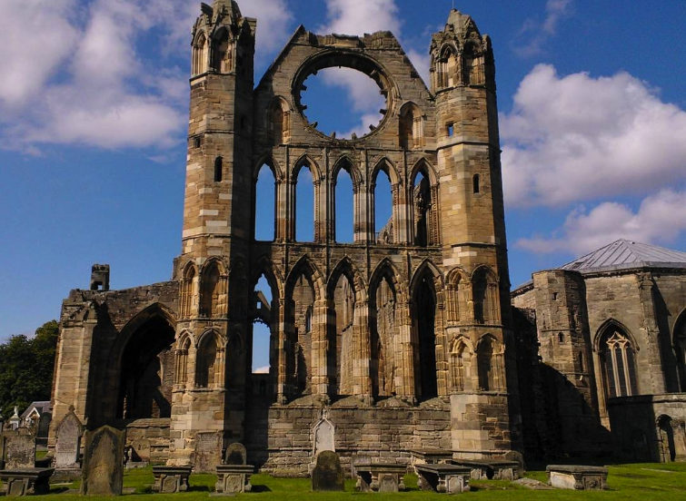
Elgin Cathedral

Day 11, June 15th: Grantown-on-Spey (Cairngorms National Park)
Overnight at The Grant Arms Hotel or similar (B)

Today we will travel to Grantown within the stunning Cairngorms National Park. Once we check into the hotel in the morning we will have the option to take a half day whisky tour to some local distilleries or a half day walking tour within the national park and it’s many trails. Evening is free.

Cairngorms
Mother Nature dealt the Cairngorms a hand full of aces. At 1,467 square miles, it is Britain’s largest National Park and located within the heart of the Scottish Highlands. The park has a large upland plateau, and is categorized as a “protected landscape” which allows for limited development within its borders. The park is home to reindeer, ospreys, eagles, wildcats and red squirrels, and boasts an extensive array of activities that range from hiking, skiing, and visiting traditional villages. The Cairngorms National Park is truly a thrilling land of adventure and discovery, and boasts natural wonders such as mountains, gorges, forests and rivers. Also within the park you will find ancient highland communities and whisky distilleries. Five of the UK's six highest mountains lie inside the park, and there are 55 “Munros” – or mountains over 3,000 ft.

Day 12, June 16th: St. Andrew’s
Overnight at Best Western Scores Hotel or similar (B, L)

We depart this natural place and travel to Ballater and the Royal Lachnagar distillery for a tasting and tour. We will have lunch along the way.

Ballater & The Royal Lachnagar Distillery
Surrounded by the glorious countryside Ballater is a picturesque Victorian village in the heart of Royal Deeside located in the Cairngorm National Park. Lying eight miles along the River Dee to the west, its rich history and royal connections are world famous. Ballater is the nearest town to Balmoral Castle, one of the residences of the Royal Family, which explains the many ‘By Royal Appointment’ signs can be seen on local shops and business. Close by is also Royal Lochnagar Distillery which produces one of Scotland’s most exclusive whiskies. A visit to the distillery is a timeless experience.

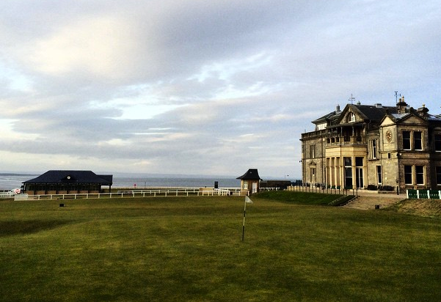
St. Andrew’s Royal Golf Club

St. Andrew’s
St Andrews is known worldwide as The Home of Golf, and also boasts Scotland's oldest university. The St Andrews Royal and Ancient Golf Club first met here in the spiritual home of golf in 1754, though it was first played here as early as the 15th century. The Old Course, which you can play (if you’re lucky), is most famous of the town's eight championship courses, and has played host to some of the world’s finest golfers at the British Open Championship over the years.

Day 13, June 17th: St. Andrew’s
Overnight at Best Western Scores Hotel or similar (B)

Today you will have a leisurely day in St. Andrew’s to golf or visit some of the many other sites around St. Andrew’s such as the St. Andrew’s Preservation Trust Museum - a lovely little museum with interesting displays and fascinating insight into all things St Andrews, the Museum of the University of St. Andrew’s - traces the classic and storied history of this prestigious school, or the remains of St Andrews Cathedral, which was Scotland’s largest cathedral and most magnificent church.

Day 14, June 18th: Edinburgh

Overnight in Hotel Parliament or similar (B, L)

After breakfast we will head towards the fishing village of Anstruther for some of the country’s best fish and chips. We will also learn some fascinating Scottish history at Falkland Palace and Dumferline Abbey before heading to our final accommodations in Edinburgh.

Anstruther
Anstruther is a charming fishing village in the East Neuk of Fife, popular with day-trippers and holidaymakers. Located south of St Andrews, Anstruther is the largest in a string of pretty, old-fashioned fishing villages along the stretch of Fife coast known as the East Neuk. Perhaps the top attraction is simply tucking into a quality fish supper from the Anstruther Fish Bar, which in recent years has won a number of awards including UK Fish and Chip Shop of the year.

Falkland Palace
Set in the picturesque village of Falkland, this palace was the favorite retreat of the Stuart dynasty, especially Mary Queen of Scots who visited for the hunting, hawking and tennis. The Palace is now in the care of the charity the National Trust for Scotland. The Royal Palace of Falkland was used as a country residence by Stuart kings and queens who used to hunt deer and wild boar in the nearby Fife forests. Mary Queen of Scots spent some of the happiest days of her tragic life here, hunting and hawking around the woods and park, which is still beautifully maintained today.

Dumferline Abbey
Dunfermline Palace and Abbey are the remains of a great Benedictine abbey founded by Queen Margaret in the 11th century. Beginning as a priory founded by Malcolm’s wife, Queen Margaret, it was re-established as an abbey by her son in 1128 and is the final resting place of King Robert Bruce, notably minus his heart, along with seven other Scottish kings. Substantial parts of the abbey buildings remain, including the vast refectory. The foundations of Queen Margaret’s church are under the present superb nave, built in the 12th century in the Romanesque style.

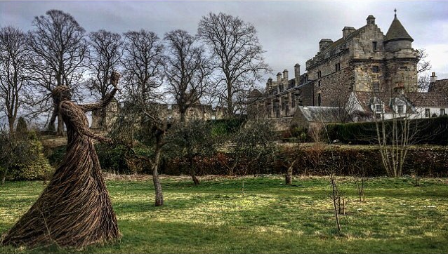
Falkland Palace

Day 15, June 19th: Transfers out - International departures

Today we will be transported to the airport for our international departures back to the US.

Cost of the Tour:

$6,895.00 per person double occupancy (Including round trip air from NYC)

$1,770.00 per person single supplement

NOTES:
- Price is subject to change due to currency exchange fluctuations or fuel surcharges
- It is possible that changes to the above itinerary may be necessary. If so, whatever is altered will be replaced by its equivalent

Included:
- International round trip air from New York (JFK) to Edinburgh
- All transportation within Scotland by private chartered bus
- All accommodations
- Local English speaking guides
- All entrance fees as per itinerary
- Meals as per itinerary (B-Breakfast, L-Lunch, D-Dinner)
- Tips to hotel maids, guides and bus drivers

Not included:
- Items of personal nature
- Airfare to and from New York’s John F. Kennedy airport

A deposit of $500.00 per person will be required to sign up no later than: November 15th, 2017. Final payment is due on December 15th, 2017.

Please make checks (no credit cards) payable to Journeys International, Inc – 49 Verano Loop – Santa Fe NM 87508. If you have any questions please call Rosa Ramirez Carlson at Journeys International, Inc. at 505-310-1863 or mail: carlsonrosa@hotmail.com

To sign up: Contact Rosa Carlson to check for available space (see above)

Fill out Booking and Release Form (last page)

Enclose your $500.00 deposit check

Enclose a photocopy of your passport

Mail to JOURNEYS INTERNATIONAL - 49 Verano Loop, Santa Fe NM 87508

Cancellation Penalties

After deposit $150.00 administrative fee

After December 15th, 2017 100% percent of total tour price

Important: Purchase of trip cancellation insurance is strongly recommended. If you have any pre-existing conditions for which you would like coverage, most companies require that you must purchase the insurance within 14 days of your first payment for the tour. You can purchase coverage just for the amount of your deposit and later increase your coverage when the final payment is made. In addition, many health insurers, including Medicare, do not provide coverage for insured persons traveling abroad. Affordable health insurance for overseas travelers is readily available with companies such as Medex, Travel Guard, Allianz Travel Insurance and similar companies. Please contact Rosa Ramirez Carlson is you have any questions or need assistance in selecting insurance.

BOOKING and RELEASE FORM – DISCOVERING SCOTLAND 2018

PLEASE ATTACH A COPY OF YOUR PASSPORT TO THE COMPLETED FORM:

First Name(s) ____________________________________ Last Name(s) ___________________________

Mailing Address _________________________________________________________________________

City _______________________________________ State _________________ Zip Code ____________

Telephone ________________________________ E-mail _____________________________________

Seat request (will do our best) _____________________ Single Supplement: Yes ____No____

Sharing with: ________________________

United Frequent Flyer #_________________________ Meal requests /Allergies ____________________

Emergency Contact: Name _______________________________________Telephone ________________

The undersigned intends travel to Scotland on a program administered by Journeys International, Inc. The undersigned has been informed that travel and other activities can be dangerous for a variety of reasons and may result in injury or loss of life and/or damage to property. The under- signed has been informed that neither Journeys International, Inc. nor anyone on its behalf has obtained insurance to insure the undersigned or her/his property. The undersigned understands that if he/she wants to insure himself/herself and his/her heirs, successors and assigns, the undersigned will obtain such insurance at his/her own cost. The undersigned hereby waives, releases, acquits, exonerates and discharges any claim, cause of action, demand or right of recovery against Journeys International, Inc., its agents, employees, heirs, successors or assigns (the released parties) for any personal injury (including psychological injury), death, damage or loss arising out of, or any way related to, the said trip to Scotland, the United States or in transit. The undersigned expressly understands that this Waiver and Release constitutes a bar to any and all claims against any of the released parties arising out of any claim waived or released herein. The undersigned has entered into this Waiver and Release of his/her own free will and accord, not being influenced by any representation of the released parties or by any other person. This document contains the entire agreement between Journeys International, Inc. and the undersigned concerning any liability, is severable and may be amended only in writing signed by Journeys International, Inc. and the undersigned. I HAVE CAREFULLY READ THE FOREGOING

_________________________ _______________________________ __________________
Print your name Signature Date

Mail completed form and copy of passport to:
Rosa Carlson, Journeys International, Inc. – 49 Verano Loop – Santa Fe NM 87508

