Remote Spain: The Foothills of the Pyrenees

A Donna Pierce & Rosa Carlson Tour

Full Itinerary

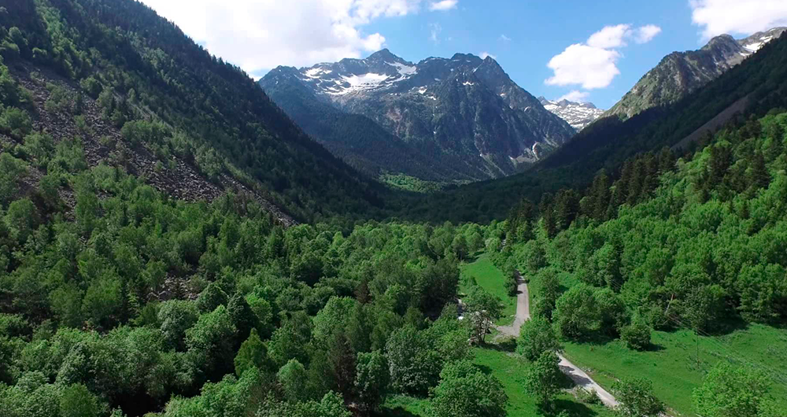

Dr. Donna Pierce and Rosa Ramírez Carlson of Journeys International, Inc., have been thinking about organizing a tour to this area for several years. The Spanish Pyrenees is a region seldom visited but so rich in natural beauty, in tiny villages, in ancient churches, and in wholesome and delicious food. Our stays will be in Hondarribia, one of the most beautiful towns of the Basque country and a stone’s throw away from San Sebastian, an enchanting city known for its art and architecture, named the Cultural Capital of Europe in 2016. We will explore Pamplona, founded by the Roman general Pompeyo in 74-75 CE, as well as Olite, the seat of the Royal Court of the Kingdom of Navarra, from 1387 until it joined Castile in 1512. Our tour continues to Jaca and Bielsa. Our home for three nights at the Parador de Vielha will allow us to deeply explore some of the many beautiful villages in the Valle de Noguera and the Vall de Aran as well as others on the way to Boi and Taull. Our stay at the spectacular Parador de Cardona will be remembered as we head out to Barcelona where we will visit the Sagrada Familia, Park Güell and other important sites. We will see many of the Romanesque churches and then their murals now in Barcelona

The tour will include slide lectures by Dr. Donna Pierce. If there is sufficient interest, informal Spanish classes and Spanish language tertulias (conversations) will be conducted throughout the trip. We will be staying in exquisite and historic hotels and Paradors, many with spectacular views of the highest peaks of the Pyrenees, throughout our stay in Spain.

Don’t miss the opportunity to join us in this well-planned and unique tour of Spain!!

Day 1, Saturday, Sept 21 – Leave US

Day 2, Sunday, Sept 22 -- Arrive Madrid and connect to the airport near San Sebastian and go straight to the wonderful parador Del Emperador in Hondarribia, on the border with France. Originally built as a fortress castle in 980 by Navarrese kings, it was restored by Charles V in the 16th century. Many of the rooms and the parador terrace have views across the Bidasoa River to France. After checking in, you can have lunch on your own and a free afternoon to rest up. Donna will lead a brief evening orientation walking tour of old town Hondarribia for those who wish. Dinner on your own in one of the many good restaurants nearby.

Parador of Hondarribia

Day 3, Monday, Sept 23 – Morning tour of Hondarribia with a local guide to see the medieval walls with the Puerta de Santa Maria, a gate commemorating the Spanish (as opposed to the Mexican) Virgin of Guadalupe, to visit the Gothic church of Santa Maria and the old fisherman’s area of Hondarribia known as La Marina. For lunch on your own, those who wish can stay in this area to enjoy the many excellent seafood restaurants or return to the old town. We will have a free afternoon to continue to recover from jet lag or to stay in the Marina area to enjoy the beaches and view of France across the bay. Possible early evening lectures. Dinner on your own. We recommend trying the local slightly sparkling white wine known as txacolí (pronounced cha-co-LEE) and/or the local ciders made from some of the 53 different types of apples grown in the Basque region.
B Parador of Hondarribia

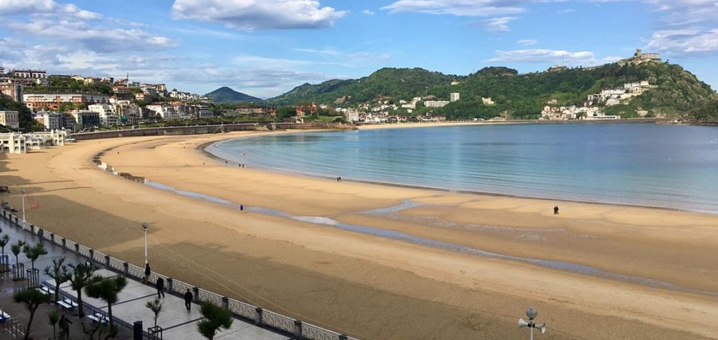
View of the Bay of Biscay in San Sebastian

Day 4, Tuesday, Sept 24 – Day trip to the spectacular and elegant beach town of San Sebastian located on a gorgeous C-shaped bay overlooking the Bay of Biscay on the Atlantic. We will have a guided walking tour of the old town with brief visits to the Church of Santa Maria with its Baroque façade and altars and the Museo de San Telmo with exhibits outlining the history and art of the area.

Since San Sebastian is known as the gastronomic center of the Basque region, we will have a special group lunch. Hopefully after lunch we will have free time to shop or walk the beach or have tea at the elegant Hotel de Londres y Inglaterra on the beach promenade with a spectacular view across the bay.
B, L Parador of Hondarribia

Day 5, Wednesday, Sept 25 - Free day in Hondarribia or to return to San Sebastian on your own (local bus stops at foot of parador elevator!). If there is enough interest, we might organize an optional group trip into France to St Jean de Luz on the Bay of Biscay or to the city of Bilbao to visit the Guggenheim Museum.
B Parador of Hondarribia

Day 6, Thursday, Sept 26 – After checking out of the parador, we will drive through the western end of the Basque Pyrenees as they descend toward the Atlantic to the city of Pamplona (Iruña in Basque) where we will check into the elegant recently-renovated Gran Hotel La Perla. The oldest hotel in Pamplona, it was Ernest Hemingway’s favorite and is described in detail in The Sun Also Rises as well as in A Moveable Feast. Located right on the main plaza, it also backs up to the Estafeta alley where the running of the bulls takes place every July.

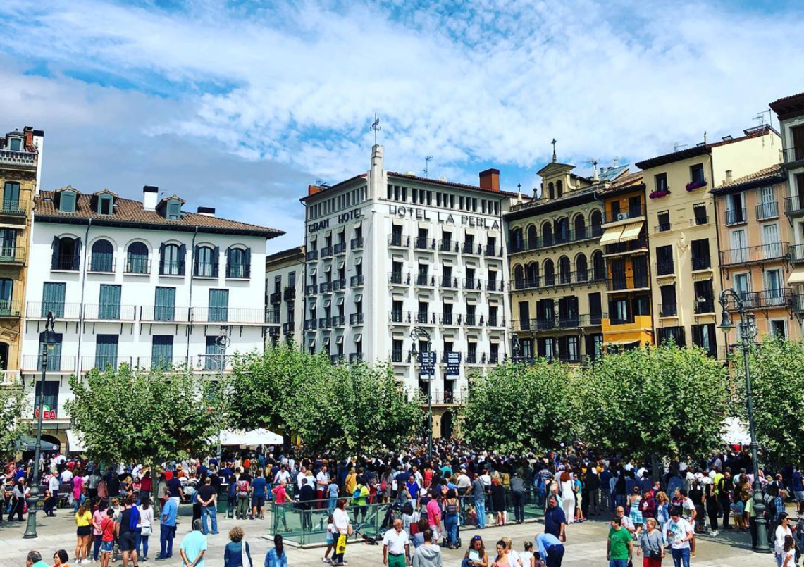
Gran Hotel La Perla in Pamplona

After a group lunch at nearby Café Iruna (also featured in Hemingway’s books), we will have a guided walking tour of the old town ending with a visit to the Gothic Cathedral with its rebuilt Rococo façade by the famous 18th-century architect Ventura Rodriguez whose work influenced architecture in colonial Mexico. On the interior, the wide arches and windows and broad walls are typical of the Navarrese Gothic style. The adjacent museum in the former Gothic cloisters now has an excellent new exhibition documenting the history of art in Navarre. Possible afternoon lectures and an evening walking tour along the medieval walls. Dinner on your own.
B, L Gran Hotel La Perla, Pamplona

Day 7, Friday, Sept 27 – Start the day with a visit to the Museo de Navarra housed in a former hospital for pilgrims on their way to Santiago and including art and artifacts illustrating the long history of the province of Navarre from Roman times through the 19th century. Next we will visit the Museo Universidad de Navarra to see its modern art collection housed in a new building by celebrity architect Rafael Moneo. Its exhibition on the history of photography is particularly interesting. Lunch and afternoon are free to stay at the museum as long as you wish, wander the charming streets of Pamplona or shop. Possible early evening lectures. Dinner on your own.
B Gran Hotel La Perla, Pamplona

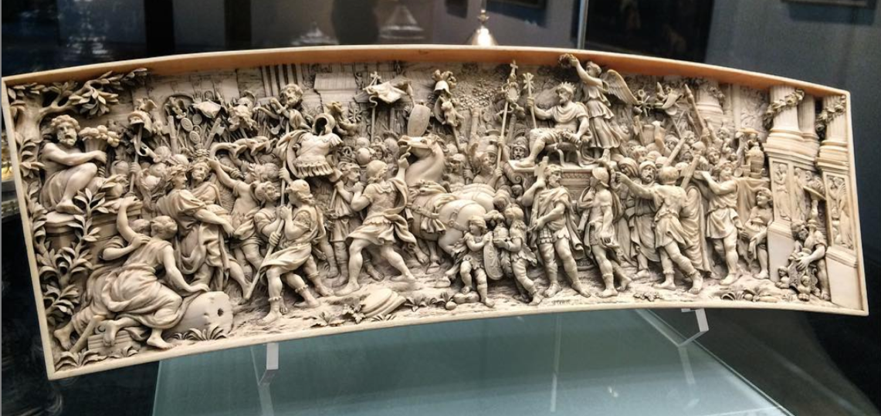
Museo de Navarra, Pamplona, Spain

Day 8, Saturday, Sept 28 – Day trip to visit the medieval town of Olite where we will have a guided tour of the fairytale castle built by King Carlos III (the Noble) of Navarre in the late 14th century and once the seat of the Court of Navarre. After a group lunch in the parador restaurant located in part of the castle, we will return to Pamplona for a free afternoon. Possible late afternoon lectures. Dinner on your own.
B, L Gran Hotel La Perla, Pamplona

Day 9, Sunday, Sept 29 – Leave Pamplona and have a late morning guided tour of the town of Jaca, one of the main entry towns after pilgrims crossed the Pyrenees from France on the Road to Santiago. We will visit the Romanesque Cathedral and tour the old town. After a group lunch we will drive to the magnificent Castle of Loarre built onto a giant rock face overlooking the Ebro Valley. Considered one of the best preserved castles in Spain, it has been the set for many movies including Kingdom of Heaven directed by Ridley Scott and starring Orlando Bloom and Liam Neeson. After our self-guided visit to the castle, we will drive on to the Bielsa Parador nestled in the skirts of the Pyrenees and at the edge of the Ordesa y Monte Perdido National Park and Nature Preserve, known as the “junior Grand Canyon,” for its rock formations.
B, L Parador de Bielsa

Day 10, Monday, Sept 30 – Drive east toward Aneto, the highest peak in the Pyrenees, ending with a trip north through the spectacular Valle de Noguera along the Garonne River with glacial lakes, wildflower meadows, and jagged peaks in the distance. After a group lunch en route, we will continue to the Parador of Vielha with its spectacular views of the Pyrennean Vall de Aran, the upper valley of the Garonne River. The breathtaking views can be seen from a giant circular glassed-in living room in the parador with a central fireplace and surrounding terrace. If time allows during the next three days, there are excellent hiking trails in the area.
B, L Parador de Vielha

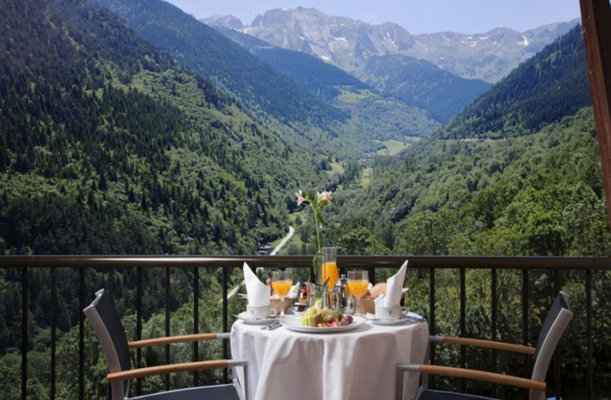
View from Parador Vielha

Day 11, Tuesday, Oct 1 – Visit the Valle de Boi known for its cluster of Romanesque churches with Lombard influence. Their slate roofs, tall belfry towers, and exceptionally fine wall frescoes (most now in the National Museum of Art in Barcelona) make them the finest Romanesque churches and villages in the Pyrenees and collectively they form a UNESCO World Heritage Site. We will drive by the enchanting villages of Erill la Vall, Berruera, Durro, and Vilaller, among others, with their narrow streets, wooden balconies and slate roofs. We will visit churches in the town of Boi and the small village of Taull (Santa Maria and Sant Climent). Later we will see the frescoes from these churches in Barcelona where they were moved for safekeeping many years ago. After a group lunch, we will return to the spectacular parador for a free afternoon to rest or hike.
B, L Parador de Vielha

Day 12, Wednesday, Oct 2 – We will journey east through the Vall de Aran to the narrow Vall de A’neu. Depending on road conditions, we will visit churches in some of these remote villages such as Arties, Salardú, Sorpe, Esterri d’Aneu, and Cardós de Esterri. After a group lunch, we will return to the parador for a free afternoon.
B, L Parador de Vielha
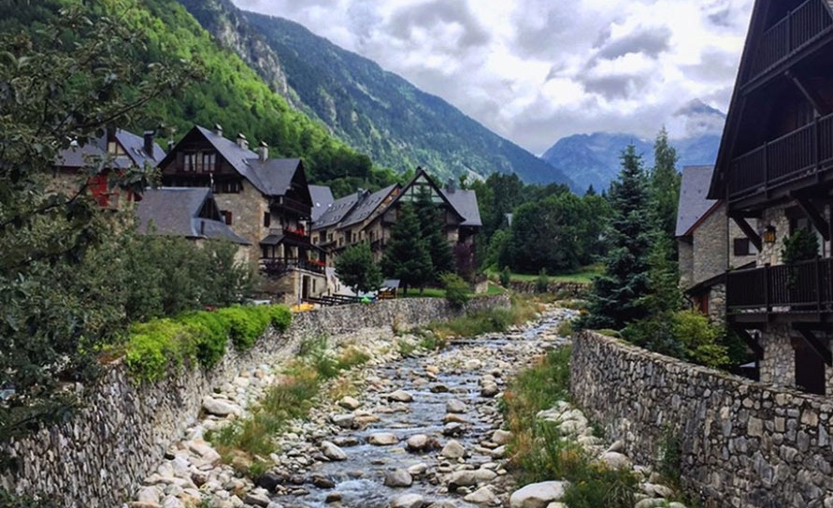
Arties, Spain in the Vall de Arán

Day 13, Thursday, Oct 3 – After checking out of the parador, we will drive to the village of Solsona for a guided walking tour of the medieval town including a brief visit to the cathedral and regional museum with Romanesque and Gothic frescoes from the area. After a group lunch, we will drive on to the village of Cardona with its parador in a 9th-century fortified castle on top of a hill looking across to the famous Muntanya de Sal (Mountain of Salt) that supplied salt to the Romans and all subsequent Spanish cultures.
B, L Parador de Cardona

Day 14, Friday, Oct 4 – Brief morning drive to Barcelona. On entering town the bus will take us past a series of monuments designed by the famous Barcelona architect Antoni Gaudí (1852-1926) including Casa Milá (Pedrera), Casa Batlló and Parque Güell with a brief stop and tour of the famous Sagrada Familia church. All of these buildings represent the international Art Nouveau style, but are executed in a distinctively Spanish way, replete with traditional majolica tilework mosaics handled in a wildly unique manner (known as modernismo). Gaudí’s organic and fanciful style became influential in Latin America in the early 20th century.

After a group lunch, we will conclude the day with an afternoon visit to the National Art Museum of Catalonia (MNAC) to see the world’s finest collection of Romanesque wall murals, including ones removed from the Valles de Boi, Aran, and D’Aneu churches we will have just visited. After our tour of the Romanesque mural galleries, we will be free to visit other galleries of choice on our own to find paintings by Velasquez, Zurburán, Rubens and Tintoretto and Catalan impressionists. Afterwards we will check into our hotel for a free evening and dinner on your own.
B, L Hotel Ciutat de Prat, Barcelona

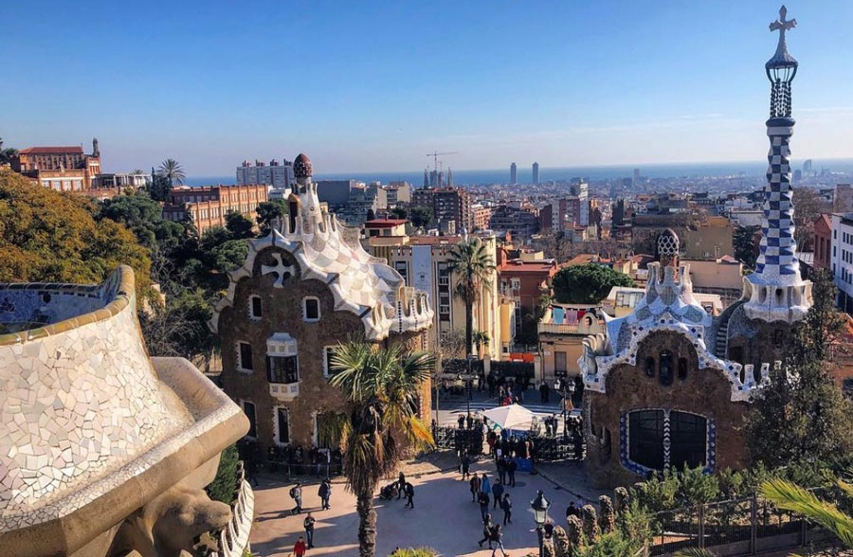
Parque Güell, Barcelona

Day 15, Saturday, Oct 5 – This morning we will have a brief guided walking tour of the Gothic Quarter, including the lovely Gothic Santa María del Mar church. When pilgrims flocked through Barcelona on their way to Santiago de Compostela in the Middle Ages, churches sprang up here in a new Spanish version of the international Gothic style, distinctive in the softer lines and more elaborate ornamentation than those of northern Europe. This was the first European architectural style introduced to the Americas and was used in many mission establishments of 16th-century Mexico.

After lunch on your own at one of the many great restaurants in the Gothic Quarter, we will be free to visit other nearby museums including the Picasso Museum which holds some of his most famous as well as some of his earliest surviving works, allowing the museum to document his evolution as an artist from the age of 9 on; the Maritime Museum set in the medieval docks for repairing ships and documenting Barcelona’s primacy in international shipping in that era; and/or the History Museum of the City where you can see the Roman archeological ruins underneath it, as well as explore the Greek, Carthaginian, Muslim, Jewish and Christian heritage of Barcelona, or to make last-minute purchases. Return to the hotel for packing and dinner on your own.
B Hotel Ciutat de Prat, Barcelona

Day 16, Sunday, Oct 6 - Leave for US or extend in Barcelona

*B=breakfast, L=lunch, D=dinner

The tour will include slide lectures by Dr. Donna Pierce. If there is sufficient interest, informal Spanish classes and Spanish language tertulias (conversations) will be conducted throughout the trip.

NOTES:
** It is possible that changes to the above itinerary and activities may be necessary. If so, whatever is altered will be replaced by its equivalent.
*Price is subject to change due to currency exchange fluctuations or fuel surcharges.

COST OF THE TOUR – DOUBLE OCCUPANCY $4,897.00
COST OF THE TOUR – SINGLE OCCUPANCY $6,572.00

PROGRAM INFORMATION
INCLUDED:
• All accommodations
• Breakfast daily and nine lunches
• Transportation throughout by chartered bus, as indicated in the itinerary
• Water on board the coach on traveling days
• Entrance fees to all sites indicated in the itinerary
• English-speaking local guides

NOT INCLUDED:
• Items of personal nature
• Tips to porters, maids, driver and guides

NOTE: The airfare is not included in the cost of the tour. Participants who have expressed interest in this tour are departing from different cities like Denver, Albuquerque, Houston or Dallas. We have obtained a group rate from Chicago (connecting in Madrid) to San Sebastian, returning from Barcelona to Chicago (non-stop). The price is $1,162.57. To qualify for the airfare, we must have at least 10 participants traveling together. I will be more than happy to discuss and make flight arrangements for you, with the group or independently. Please contact me for more information, my contact info is listed below.

Important: Purchase of trip cancellation insurance is strongly recommended. If you have any pre-existing conditions for which you would like coverage, most companies require that you must purchase the insurance within 14 days of your first payment for the tour. You can purchase coverage just for the amount of your deposit and later increase your coverage when the final payment is made. In addition, many health insurers, including Medicare, do not provide coverage for insured persons traveling abroad. Affordable health insurance for overseas travelers is readily available with companies such as Medex, Travel Guard, Allianz Travel Insurance and similar companies.

Rosa Ramírez Carlson of Journeys International, Inc. is handling all air and land arrangements. For any questions about airfare or if you wish to go early or extend your trip, please contact Rosa Ramirez Carlson at the following email address: carlsonrosa@hotmail.com or phone: 505 310-1863.

For other details and questions contact Dr. Donna Pierce at donnaleeprc@aol.com or 720 352-7559.

JOURNEYS INTERNATIONAL, INC.
49 Verano Loop
Santa Fe NM 87508
505-310-1863

