Wonders of Morocco
October 11 – 26, 2019

Rosa Ramirez Carlson & Journeys International, Inc.

Known to the Arabs as al-Maghreg al-Aqsa, the “the farthest land of the setting sun”, Morocco is a place where fragrant gardens mesh with ancient turreted cities and crashing Atlantic waves to form one of the most memorable travel experiences on the planet. Together we will explore this beautiful country as we visit the sites of Morocco – the Roman ruins, the ancient cities, the mountain kasbahs and the elegant Islamic monuments. We will learn all about the crafts of this fascinating country – contemporary and traditional, urban and rural, from rich brocades and embroideries to flat weaves and pile rugs full of color and character, a reflection of the diversity of the country and its people. We invite you to explore the Wonders of Morocco with us!

Day 1 – 11 October Friday – Depart New York
Today we will board our international flight at the John F. Kennedy airport in New York City. We will board Royal Air Maroc flight #201 leaving at 9.05PM. Overnight on board AT #201

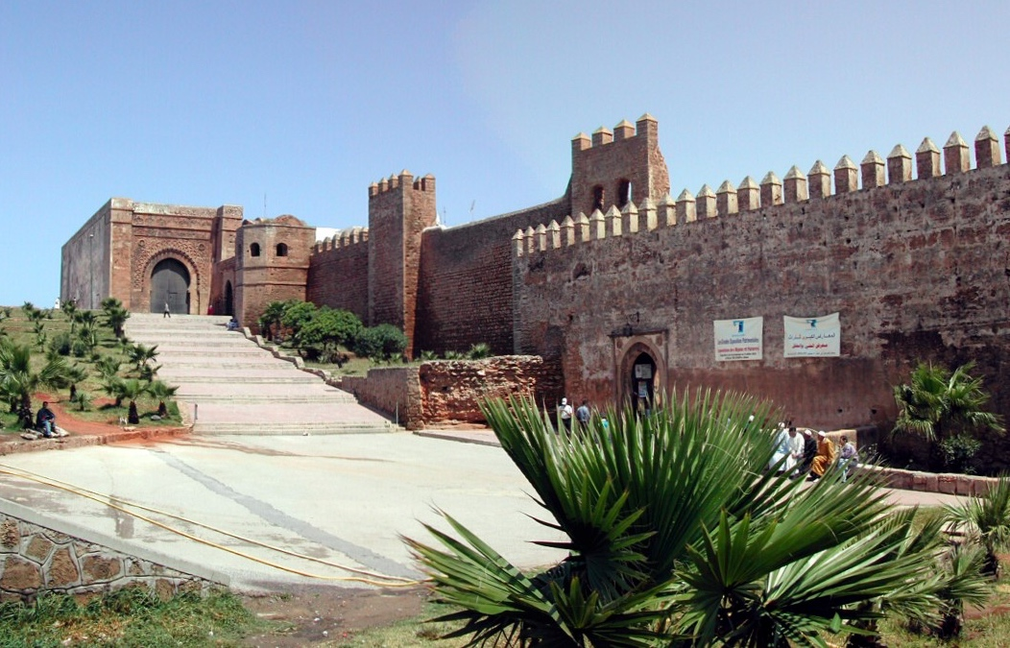
Kasbah of the Udayas, Rabat

Day 2 – 12 October Saturday – Rabat (B, L)*
We land in Casablanca at 8.55am local time. After clearing customs and immigrations we will be met and have a brief tour of Casablanca before going by road to the city of Rabat. Rabat has been the political capital of Morocco since 1912. Located in the southern bank of the Oued Bou Regreg estuary, in its 2,500 years of history Rabat’s wheel of fortune has turned twice to elevate it as an Imperial capital and a maritime trading power while in between it has been reduced to a humble village. In the afternoon we will visit the Kasbah des Oudaias, built on the bluff overlooking the Atlantic Ocean, with great views over the estuary and across to Sale. Inside the kasbah, we will visit a 17th century palace built by Moulay Ismail, which houses the Museum of Moroccan Arts.

Overnight at Riad Kalaa or similar

Day 3 – 13 October Sunday – Chefchaouen (B, L)
(Chaouen, Chawen or Xaouen) is a gorgeous mountain city in northeastern Morocco. It's no wonder that tourists flock here — this humble town is the embodiment of almost every Moroccan cliché. The picturesque medina, set against the dramatic backdrop of the Rif Mountains, is filled with white-washed homes with distinctive, powder-blue accents, and the call to prayer rings out of several mosques around the town in chorus.

Overnight Riad Dar Echchaouen or similar

Day 4 – 14 October Monday – Chefchaouen (B)
We will have an orientation tour in the morning and the afternoon is free to explore and photograph this wonderful town.

Overnight at Riad Dar Echchaouen or similar

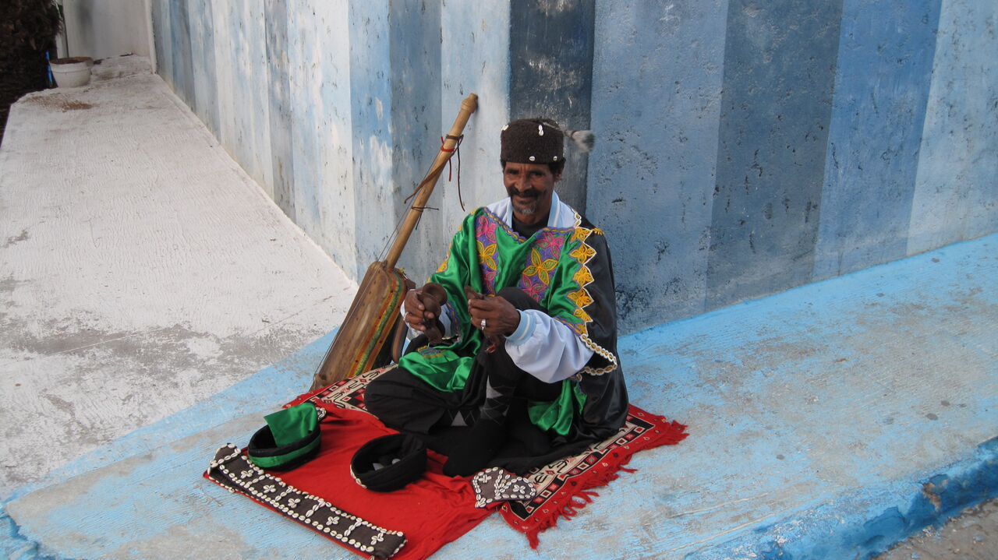
Chefchaouen

Day 5 – 15 October Tuesday – Fes (B, L)
After breakfast we will depart Chefchaouen for the fabled city of Fes. Along our way to Fes we will first explore Morocco’s best preserved Roman ruins at Volubilis, a Unesco World Heritage site. The ruins of Volubilis date from the 2nd and 3rd centuries AD, although, it may have been originally settled by Carthaginian traders in the 3rd century BC. One of the Roman Empire’s most remote outposts, it was annexed in about AD 40. Volubilis’ population of Berbers, Greeks, Jews and Syrians continued to speak Latin and practice Christianity right up until the coming of Islam. Volubilis was inhabited until the 18th century, when its marble was plundered to build Moulay Ismail’s palaces in Meknes. We will also visit Meknes as we head first to the gate of Bab El Mansour, located on top of a hill; it is the most impressive monumental gateway in all Africa. This marks our entrance to the Imperial City, a bewildering enclosure surrounded by over 16 miles of massive pise walls. After visiting the area, we will continue on to Fes.

Overnight at Riad Salam or similar

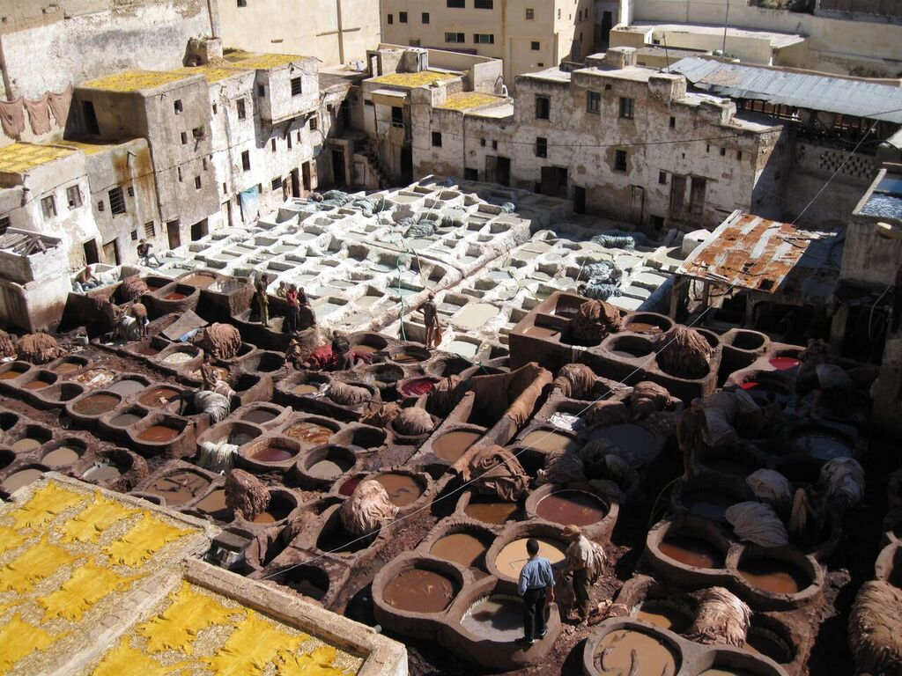
Tanneries in Fes

Day 6 – 16 October Wednesday – Fes (B, L)
Today we will have a full day tour and explore the oldest of the Imperial cities - Fes is arguably the symbolic heart of Morocco and is the most complete Islamic medieval city in the world. Fes was founded in the 9th century as the capital of the Idrissid State, the first Muslim kingdom of Morocco. Fes grew in wealth and remained the acknowledged religious and cultural center of Morocco, despite the establishment of new administrative capitals at Marrakech and then Rabat. Its golden period of wealth, fame and prosperity was in the 13th and 14th centuries under the Merenid sultans. The city is divided in three parts: The Fez-el-Bali (Old Fes) is the enigmatic and fiercely Muslim medina, a maze of hidden quarters, fondouqs, medersas and mosques, with narrow streets inaccessible to cars. Fes Jdid (New Fes) is the 13th century imperial city to the west of the medida, which is still dominated by the royal palace and the mellah, the old Jewish ghetto.

Overnight at Riad Salam or similar

Day 7 – 17 October Thursday – Fes (B)
Fes has been, and still is, the artisanal capital of Morocco. The incredible choice and quality of crafts, along with reasonable prices, make Fes a must see destination for any art lover. We will visit the Musee du Batha, also known as the Museum of Moroccan Arts, on Place de l’Istiqlal. Built as a Hispano-Moorish palace more than one hundred years ago by Moulay al-Hassan and Moulay Abd al-Aziz, it houses an excellent collection of historical and artistic artifacts, including fine woodcarvings, zellij work and sculpted plaster. There is also some fine Fassi embroidery, colorful tribal carpets and a well-known ceramic collection dating from the 14th century to the present. In the afternoon we will have local guides for the visits to the souks. The most famous souks, or Arab marketplaces, are the dyers market along the Rue de Teinturies or the Tanner’s Quarters. The dyers market is the best place to see the dying vats which have been used for centuries to soak the skins of sheep, goat, cows and camels after they have their hair and flesh removed. You will see many tanned hides colored with natural pigments ranging from shades of brown, black, turquoise fuchsia, yellow and orange.

As a UNESCO World Heritage Site, Fes is also considered one of the most religious and spiritual cities in Morocco. It is host to some incredible attractions to visit including the Jewish Mellah, the Jewish Synagogue, the Bou Inania Medersa and the Jewish Cemetery & Tomb of Solica.

Overnight at Riad Salam or similar

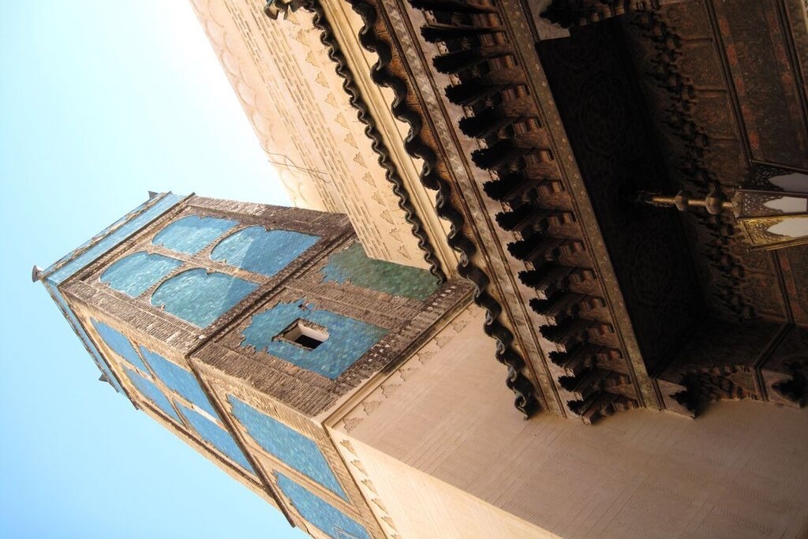
Mosque Sidi Ahmed Tijani, Fes

Day 8 – 18 October Friday – Afourar (B, L, D)
After breakfast we will depart Fes. We will cross the Tadla plains and go through Ifrane, established in 1929 as a summer hill station for the French officials and it remains a favorite gathering ground for the rich and influential. We will continue on to Azrou and Khenifra. The extensive market town of Khenifra stretches along both banks of the Oued Oum er Rbia, surrounded by the folding hills of the Middle Atlas Mountains. The houses of Khenifra are a deep red with doors and windows painted green which reflect the region’s fierce red soil and spring vegetation. We continue through Beni Mellal, the provincial capital. From here we can see the second highest peak in the country, Jebel M-Goun. Late arrival in Afourar

Overnight at Chems Tazarkount Afourar or similar

Day 9 – 19 October Saturday – Ait BouGoumez Valley (B, L, D)
Located at the foot of the M’Goun range and its ten peaks that soar over 11,000 feet, the long isolated valley of Ait Bougmez is enchanting. We will overnight at the Dar Itrane Ecolodge, a guesthouse that actively supports the sustainability of the Bougmez Valley by providing work, directly and indirectly to the inhabitants of the surrounding villages, protecting the environment by various actions (waste management, using clean “energy”, and encouraging environment-friendly practices).

Overnight at Dar Itrane or similar

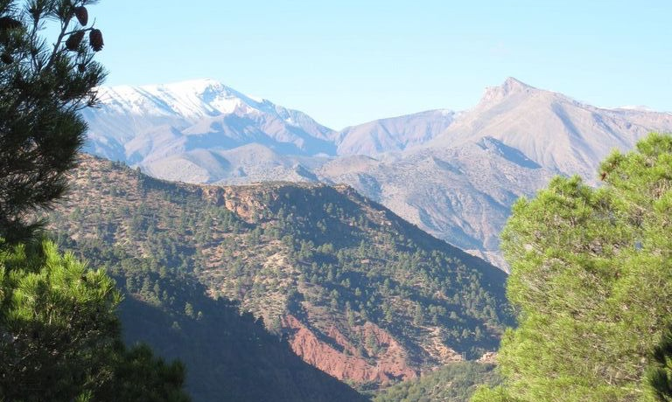
Ait BouGoumez Valley

Day 10 – 20 October Sunday – Marrakech (B, L)
We have traveled far to see one of the best kept secrets of Morocco, a hidden Shangri-La, the green fields at the heart of the Ait BouGoumez Valley contrast sharply with the ochre of the arid mountains; in addition to the surrounding natural beauty, the architecture is a stunning tribute to Morocco’s more traditional way of life, with its remote and friendly Berber villages tucked high up on the plateau. We spend the morning exploring this beautiful region before we leave this enchanted valley to travel the 200 kilometers to Marrakech.

Overnight at Riad Slitine or similar

Day 11 – 21 October Monday – Marrakech (B, L)
Marrakech, founded almost 1,000 years ago, is one of the great cities of the Maghreb and home to the most perfect Islamic monument, the Koutoubia Mosque. Our full day tour of Marrakech will include visits to the towering 12th century Koutoubia minaret, the Menara Gardens, the Medersa (Koranic University) ben Youssef and the medieval Koubba. We will visit the Museum of Moroccan Arts and the colorful souks (marketplaces) of Marrakech, where you will see traditional artisans and be offered explanations of their crafts (using methods that their fathers and grandfathers taught them).

Overnight at Riad Slitine or similar

Day 12 – 22 October Tuesday – Marrakech (B)
A full day is available for independent activities. There is much to do in Marrakech including visiting the Yves Saint Laurent Museum of Marrakech (opened in 2017) and Jardin Marjorelle next door, spending the afternoon at a local bath house (hammam), visiting the Dar si Said Museum, which displays fantastic Moroccan architecture and objects. Also the Marrakech Museum, housed in the Dar Menebhi Palace, boasts embroidery, weapons and contemporary art. For historical imagery of the city, visit the Maison de la Photographie. In the new part of town, visitors can find many contemporary art galleries displaying work from local talent. Not to be missed is the Musee Boucharouite, relatively small, but it will prove very interesting for anyone interested in traditional carpets and rugs.

Overnight at Riad Slitine or similar

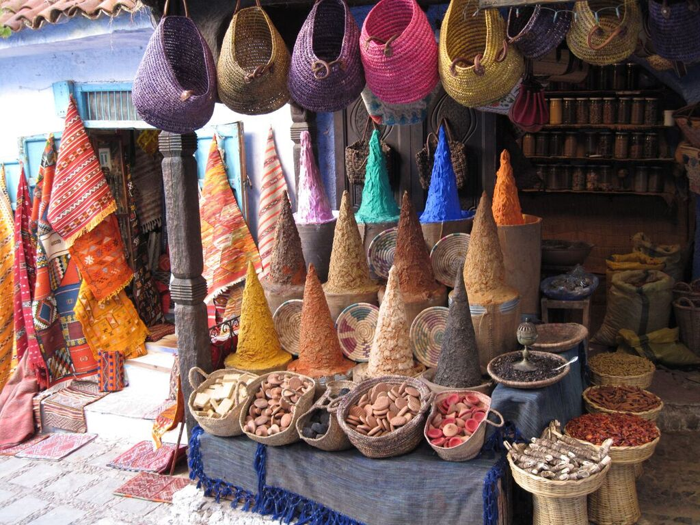
Colorful Souks of Marrakech

Day 13 – 23 October Wednesday – Essaouira (B)
We leave Marrakech and travel west to the city of Essaouira. Along the way we will stop in the town of Chichaoua which was the chief souk of the Oulad Bou Sbaa, “the sons of the lions”. They first established themselves in the Tafilalet and Draa Valley in the 13th century. Half the tribe was recruited by a Merenid prince, Abou el Abbas, in his struggle for the throne and was later posted on land between Marrakech and Essaouira in order to control the Berber tribes of Haha. Their carpets were much sought after in the 19th century, and in 1936 a cooperative was established at Chichaoua to maintain their quality. We continue to Essaouira.

Overnight at Hotel Dar L’oussia Essaouira or similar (B)

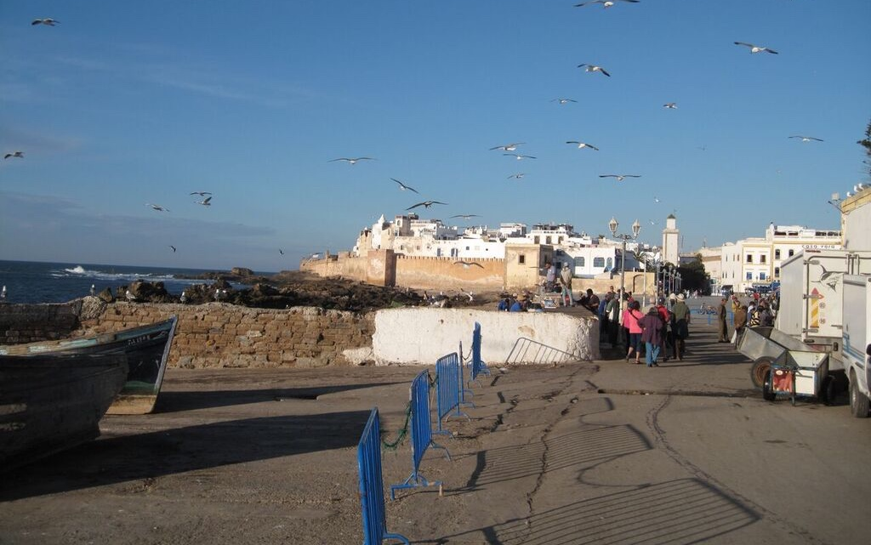
The Port City of Essaouira

Day 14 – 24 October Thursday – Essaouira (B)
This is the most enchanting town on the coast of Morocco. The 18th century battlements encircle the old town and port which overlook a scattering of barren wave-worn islands. A great sandy bay sweeps out to the south whilst wooded hills dominate the skyline to the east. The quarters of the town, the Medina, the Kasbah and the Mellah fully express the exoticism of Morocco. The dark alleys are broken with frequent arches and the women of the town are mysteriously concealed under their enveloping haiks. Today is free for independent activities.

Overnight at Hotel Dar L’oussia Essaouira or similar

Day 15 – 25 October Friday – Casablanca (B)
We will have a leisure departure for Casablanca where we will arrive in time to explore the medina and maybe enjoy a wonderful seafood dinner. With a surplus of things to do, historic and monumental buildings and the latest in contemporary art and cuisine, the Medina continues to grow and delight visitors from around the world. It is a colorful hub of vibrant shops, intricate architecture, brilliant markets and enthusiastic bartering.

Overnight at Kenzi Basma or similar

Day 16 – 26 October Saturday – USA (B)
Today we will have a free morning to further explore and to get ready for our afternoon departure. Our Royal Air Maroc flight # 200 will leave Casablanca at 4.30PM and arrive at John F Kennedy airport at 7.20PM. Welcome home!
*B=breakfast, L=lunch, D=dinner

COST OF THE TOUR – DOUBLE OCCUPANCY $4,475.00
COST OF THE TOUR – SINGLE OCCUPANCY $4,950.00

Cost of tour includes:
- Round trip air transportation between New York and Casablanca.
- Transfers and excursions by private bus with the assistance of local bilingual guides.
- Meals as per itinerary.
- Accommodations at the hotels mentioned.
- Tips to porters and in restaurants.

Not included:
- Airfare between Albuquerque and New York
- Meals not specified on itinerary
- Drinks and beverages
- Items of personal nature
- Tips to drivers and guides

A deposit of $1,000.00 is required to reserve a space. Please return the completed Booking and Release Form including a photocopy of your passport and your deposit check. Final payment is due on May 15th, 2019

Cancellation Penalty:
After deposit $150.00 administrative fee
After final payment 100% penalty

Although this is not a strenuous trip, in order to enjoy the tour, participants must generally be in good health. Therefore, it is imperative that persons with medical problems make them known to us as soon as possible prior to departure. Journeys International, Inc. and associated companies reserve the right to disqualify a tour participant at any time if, in the sole judgment of such entities, a tour participant is not deemed by them to be medically fit for travel. Such entities assume no liability regarding provision of medical care.

Important: Purchase of trip cancellation insurance is strongly recommended. If you have any pre-existing conditions for which you would like coverage, most companies require that you must purchase the insurance within 14 days of your first payment for the tour. You can purchase coverage just for the amount of your deposit and later increase your coverage when the final payment is made. In addition, many health insurers, including Medicare, do not provide coverage for insured persons traveling abroad. Affordable health insurance for overseas travelers is readily available with companies such as Medex, Travel Guard, Allianz Travel Insurance and similar companies.

JOURNEYS INTERNATIONAL, INC.
49 Verano Loop, Santa Fe NM 87508
505-310-1863 | info@journeys-international.com

